# [***82 FR 24487***](https://advance.lexis.com/api/document?collection=administrative-codes&id=urn:contentItem:5NNH-BB70-006W-803B-00000-00&context=)

Vol. 82, No. 102, Tuesday, May 30, 2017

Rules and Regulations

**Reporter**

82 FR 24487 *

***Federal Register* > *2017* > *May* > *Tuesday, May 30, 2017* > *Rules and Regulations* > *COMMODITY FUTURES TRADING COMMISSION (CFTC)***

**Title:** **Whistleblower Awards Process**

**Action:**  Final rule.

**Agency**

COMMODITY FUTURES TRADING COMMISSION (CFTC)

**Identifier:** **RIN 3038-AE50**

**Administrative Code Citation**

**17 CFR Part 165**

**Synopsis**

**SUMMARY:** The Commodity Futures Trading Commission ("Commission") is amending its ***regulations*** and forms to enhance the process for reviewing whistleblower claims and to make related changes to clarify staff authority to administer the whistleblower program. The Commission also is making appropriate rule amendments to implement its reinterpretation of the Commission's anti-retaliation authority.

**Text**

**SUPPLEMENTARY INFORMATION:** The Commission is amending its rules in §§ 165.1 through 165.19 and appendix A, and adopting new rule § 165.20 and appendix B as well as amending Forms TCR ("Tip, Complaint or Referral") and WB-APP ("Application for Award for Original Information Provided Pursuant to Section 23 of the Commodity Exchange Act").

**I. Background**

In 2011, the Commission adopted its part 165 ***regulations***, which implement Section 23 of the Commodity Exchange Act ("CEA"), [*7 U.S.C. 26*](https://advance.lexis.com/api/document?collection=statutes-legislation&id=urn:contentItem:4YF7-GT91-NRF4-40PG-00000-00&context=), by establishing a regulatory framework for the whistleblower program. n1 Part 165 provides for the payment of awards, subject to certain limitations and conditions, to whistleblowers who voluntarily provide the Commission with original information about a violation of the CEA that leads to the successful enforcement of an action brought by the Commission that results in monetary sanctions exceeding $ 1,000,000 ("Covered Action"), or the successful enforcement of a Related Action, as that term is defined in the rules.

n1 *See* Whistleblower Incentives and Protection, [*76 FR 53172*](https://advance.lexis.com/api/document?collection=administrative-codes&id=urn:contentItem:53MN-T5F0-006W-81BF-00000-00&context=) (Aug. 25, 2011).

The award amount must be between 10 and 30 percent of the amount of monetary sanctions collected in a Covered Action or a Related Action and is paid from the CFTC Customer Protection Fund. The Commission has discretion regarding the amount of an award based on the significance of the information, the degree of assistance provided by the whistleblower, and other criteria.

Since the whistleblower program was established in 2011, the need for certain improvements has become apparent. In order to address that need the Commission proposed amendments to the part 165 rules ("Proposal"). n2 As explained further below, these rules provide for targeted revisions to the claims review process and to the authority of staff to administer the **[*24488]** whistleblower program. The Commission also proposed to amend the rules to implement its anti-retaliation authority under Section 23(h)(1) based on a reinterpretation of that authority. Finally, the Commission proposed to amend its rules to permit whistleblowers to receive awards based on both Covered Actions and the successful enforcement of Related Actions, as defined in the rules.

n2 Whistleblower Awards Process, [*81 FR 59551*](https://advance.lexis.com/api/document?collection=administrative-codes&id=urn:contentItem:5KKB-KRY0-006W-838K-00000-00&context=) (Aug. 30, 2016).

The Commission received seven comment letters in response to the Proposal. Most of the comment letters focused on specific aspects of the proposed rule amendments and made targeted recommendations and suggestions. Three of the comment letters were from private individuals, two were from law firms with whistleblower practices, and two were from whistleblower advocacy groups. n3 Most of the comments received were generally supportive of the Commission's whistleblower program and proposed changes to the rules. One comment letter was critical of the current process for handling whistleblower award claims but did not provide specific comments on the proposed rules. n4 One of the whistleblower advocacy groups incorporated by reference the comment letter previously submitted by the other group. n5

n3 *See,* respectively, the following: Letter dated September 12, 2016, from Joseph N. Perlman; Letter dated September 16, 2016, from Chris Barnard; Letter dated September 27, 2016, from Matthew Erpen; Letter dated September 29, 2016, from Robert D.M. Garson, Garson, Segal, Steinmetz, Fladgate LLP (GS2Law); Letter dated September 29, 2016, from Eric L. Young, Esq., and James J. McEldrew, Esq., McEldrew Young (MY); Letter dated September 28, 2016, from Jacklyn N. DeMar, Acting Director of Legal Education, Taxpayers Against Fraud (TAF); and Letter dated September 29, 2016, from Stephen M. Kohn, Executive Director, and David K. Colapinto, General Counsel, National Whistleblower Center (NWC).

n4 *See* Joseph N. Perlman comment letter.

n5 *See* NWC comment letter.

**II. Description of Final Rules**

The Commission is adopting the amendments to its part 165 whistleblower rules as set forth in the Proposed Rules with certain changes made in response to public comments. The amendments and the public comments relevant to each amendment are discussed below. n6

n6 The public comments on the Proposed Rule are available at [*https://comments.cftc.gov/PublicComments/CommentList.aspx?id=1733*](https://comments.cftc.gov/PublicComments/CommentList.aspx?id=1733)*.*

*Eligibility Requirements for Consideration of an Award*

a. Proposed Rule

The Commission proposed targeted changes to the rules relating to consideration of an award. The Commission proposed to revise Rule 165.5 to make clear that a claimant may receive an award in a Covered Action, in a Related Action, or both. Also in Rule 165.5, the Commission proposed to make clear that a claimant may be eligible for an award by providing the Commission original information without being the original source of the information, and the Commission provided the public with notice that the Commission has discretion to waive its procedural rules based upon a showing of extraordinary circumstances.

In addition, the Commission proposed to revise the definition of "original source" in Rule 165.2(l) to extend the timeframe from 120 to 180 days that a whistleblower has to file a Form TCR pursuant to Rule 165.3 after previously providing the same information to Congress, any other federal or state authority, a registered entity, a registered futures association, a self-regulatory organization, or to any of the persons described in Rule 165.2(g)(4) and (5).

b. Comments Received

The Commission received several comments regarding the proposed changes to the requirements for consideration of an award.

Proposed Rule 165.5(b) removed being the original source of information received by the Commission from the eligibility criteria for an award. The Commission received one comment which endorsed this approach. n7

n7 *See* TAF comment letter.

The Commission received two comments regarding the Commission's proposal to amend Rule 165.5(c) to allow the Commission to waive procedural requirements in extraordinary circumstances. Both commenters supported the proposed change to this rule. n8 One commenter noted that the proposed change to this rule is consistent with the overall policy goals of the whistleblower program and that whistleblowers have varying levels of sophistication and familiarity with the procedural requirements. n9 Another commenter noted that rigid application of the procedural requirements would undermine the spirit of Congress when it created the whistleblower program and that the proposed change would further encourage whistleblowers to provide information even when they may not have followed all of the technical rules to be eligible for an award. n10

n8 *See* TAF and MY comment letters.

n9 *See* TAF comment letter.

n10 *See* MY comment letter.

Proposed Rule 165.2(l) extended the deadline from 120 to 180 days that a whistleblower has to make a submission to the Commission and retain status as the original source of information after first submitting the information to Congress, any other federal or state authority, a registered entity, a registered futures association, a self-regulatory organization, or to any of the persons described in paragraphs (g)(4) and (5) of Rule 165.2 to be eligible for an award. The Commission received two comments supporting this proposed change. n11 One commenter stated that many whistleblowers are often at or beyond the 120-day period before considering external reporting because they wait for the outcome of the internal investigation before reporting externally and internal investigations often take some time. This commenter also stated that while 180 days is a substantial improvement, an even longer time frame would help ensure that well-intentioned individuals receive full credit for their information. n12

n11 *See* TAF and MY comment letters.

n12 *See* MY comment letter.

The other commenter agreed that the period of eligibility should be lengthened to 180 days but urged the Commission to state that the 180-day period refers only to the whistleblower's "look back" eligibility to retain original source status and that whistleblowers will not lose that status or eligibility for an award if they perfect their submission to the Commission after 180 days elapse. This commenter also urged the Commission to revise Rule 165.2(l)(2) to include individuals who first provide information to foreign governments or self-regulatory authorities because of the global nature of the commodities markets and the increasing number of international whistleblowers participating in the Dodd-Frank whistleblower programs. This commenter went on to state that there is no persuasive policy reason for excluding such persons from original source status because some of the Commission's recent enforcement cases were brought with the cooperation of foreign authorities and the proposed rules allow for whistleblower awards based on Related Actions by certain foreign authorities. Hence, this commenter argued that if whistleblowers may receive awards based on Related Actions undertaken by foreign authorities, those whistleblowers should be entitled to original source eligibility in instances where they report to a foreign authority prior to reporting to the Commission. n13

n13 *See* TAF comment letter. **[*24489]**

c. Final Rule

The Commission received no comments regarding the proposed revision in Rule 165.5(a)(3) that makes clear that a claimant may receive an award in a Covered Action, in a Related Action, or both and, accordingly, is adopting the amendment as proposed.

With respect to the proposed revision to Rule 165.5(b), the Commission believes that removing the requirement that the whistleblower be the original source of information received by the Commission is consistent with Section 23(b)(1), and will prevent the potential situation where a claimant reports internally before providing information to the Commission and the employer self-reports the violation of the CEA, thereby foreclosing the claimant's eligibility for an award because the employer is the "original source" of the information. The Commission is adopting this amendment as proposed.

The Commission has also decided to adopt as proposed Rule 165.5(c), which clarifies that the Commission may waive any procedural requirements upon a showing of extraordinary circumstances.

After consideration of the comments on Rule 165.2(l), the Commission has decided to adopt the rule with one change, a conforming change and a minor correction. The Commission is adding foreign futures authorities n14 to the authorities and entities to which a claimant may provide information prior to filing a Form TCR and retain original source status. This change is consistent with the list of agencies and authorities in Section 23(h)(2)(C) with which the Commission can share information received from a whistleblower if necessary or appropriate to accomplish the purposes of the Commodity Exchange Act and protect customers. The Commission understands that individuals who are located outside the United States might decide to approach a local authority prior to providing information to the Commission. As a result, and in consideration of the global nature of the futures and swaps markets and the number of the Commission's recent enforcement actions that have been undertaken with the cooperation of foreign governments, the Commission believes it is appropriate to expand the list of entities in Rules 165.2(l)(1)(i) and 165.2(l)(2). In addition, the Commission is adding registered entity and registered futures association to, and removing futures association from the list of authorities in Rule 165.2(i)(2); and adding registered entity and registered futures association to Rule 165.2(l)(1)(i) in order to conform those rules to existing language in Rules 165.4(a)(2) and 165.11 and to Section 23(h)(2)(C)(i). The Commission is correcting a typographical error in Rule 165.2(l)(2) by removing "of any" and correcting an omission by inserting "local" in the list of authorities in the first sentence.

n14 Section 1a(26) of the CEA defines foreign futures authority as any foreign government, or any department, agency, governmental body, or regulatory organization empowered by a foreign government to administer or enforce a law, rule, or ***regulation*** as it relates to a futures or options matter, or any department or agency of a political subdivision of a foreign government empowered to administer or enforce a law, rule, or ***regulation*** as it relates to a futures or options matter.

The Commission also clarifies that the 180-day timeframe in Rule 165.2(l)(2) relates only to the date on which the Commission will consider a whistleblower's original information to have been received. Filing a Form TCR more than 180 days after reporting information to another authority does not strip a whistleblower of original source status or render a whistleblower ineligible for an award. Also, the Commission is amending Rule 165.2(i)(3) to extend the time from 120 to 180 days in order to conform that rule to the extension of the timeframe in Rule 165.2(1)(2).

*Award Claims Review Under Rule 165.7*

a. Proposed Rules

The Commission proposed several changes to the award claims review process under Rule 165.7 to better define and specify each step in the process. Those steps were spelled out in proposed new paragraphs (f) through (l), along with new provisions regarding withdrawing award applications in proposed paragraph (d) and disposition of claims that do not relate to Notices of Covered Actions ("NCAs") or final judgments in Related Actions in proposed new paragraph (e). The proposed amendments would establish a review process similar to that established under the SEC's whistleblower rules. n15 Specifically, the Commission proposed to discontinue the Whistleblower Award Determination Panel and replace it with a review process handled by a Claims Review Staff designated by the Director of the Division of Enforcement in consultation with the Executive Director, with the Claims Review Staff being assisted by the Whistleblower Office staff within the Division of Enforcement. The proposed rules also would provide an additional means for the submission of the required Form WB-APP, Application for Award for Original Information Provided Pursuant to Section 23 of the Commodity Exchange Act, in Rule 165.7(b)(1); explain the deadline for filing Form WB-APP under different timing scenarios for final judgments in covered judicial or administrative actions and Related Actions in proposed Rule 165.7(b)(3); and make a conforming change by renumbering prior paragraph (e) in Rule 165.7 as paragraph (l).

n15 *See* [*17 CFR 240.21F-10(d)*](https://advance.lexis.com/api/document?collection=administrative-codes&id=urn:contentItem:5NBM-FN10-008G-Y158-00000-00&context=)-(h) (2014).

Proposed Rule 165.7(d) would permit a claimant to withdraw an award application at any point in the review process by submitting a written request to the Whistleblower Office.

Proposed Rule 165.7(e) addressed the Commission's experience of receiving a number of Form WB-APPs that appear to be unrelated to NCAs or final judgments in Related Actions as well as Form WB-APPs that do not relate to a previously filed Form TCR. In order to reduce the administrative burden on the Commission, the Commission proposed that such facially ineligible claims primarily be handled by the Whistleblower Office. The Whistleblower Office would notify the claimant of the deficiencies in the Form WB-APP and provide an opportunity for the claimant to correct the deficiencies or withdraw the claim before the finalization of the denial of the claim. If the claimant does not correct the deficiencies or withdraw the claim, the Whistleblower Office would notify the Claims Review Staff of the proposed denial, which would be called a Proposed Final Disposition, and any member of the Claims Review Staff would have the opportunity to request review of the proposed denial. If no member of the Claims Review Staff requests review, the Proposed Final Disposition would become the final order of the Commission. If a member of the Claims Review Staff requests review, the Claims Review Staff would review the record for the denial and either remand to the Whistleblower Office for further action or issue a final order of the Commission, which consists of the proposed denial.

In Rule 165.7(f), the Commission proposed that the Claims Review Staff would evaluate all timely award applications submitted on a Form WB-APP in response to the NCA or a final judgment in a Related Action. During the review process, the Whistleblower Office may require that claimants provide additional information, explanation, or assistance as set forth in Rule 165.5(b)(3). For award claims on Related Actions, as proposed in Rule 165.7(f), the Whistleblower Office may request additional information from the claimant to demonstrate that the **[*24490]** claimant voluntarily provided the governmental agency, regulatory authority, or self-regulatory organization the same original information that led to the Commission's successful enforcement action and the successful enforcement of the Related Action. The Whistleblower Office may also seek assistance and confirmation from the other agency in making this determination.

In Rule 165.7(g)(1), the Commission proposed that following the initial evaluation by the Claims Review Staff, the Claims Review Staff would issue a Preliminary Determination setting forth a preliminary assessment as to whether the claim should be granted or denied and, if granted, setting forth the proposed award percentage amount. The Whistleblower Office would send a copy of the Preliminary Determination to the claimant. The proposed amendments would allow a claimant the opportunity to contest the Preliminary Determination.

In Rule 165.7(g)(2), the Commission proposed that the claimant could take any of the following steps in response to a Preliminary Determination:

* Within thirty (30) calendar days of the date of the Preliminary Determination, the claimant may request that the Whistleblower Office make available for the claimant's review the materials that formed the basis of the Claim Review Staff's Preliminary Determination.

1. Within sixty (60) calendar days of the date of the Preliminary Determination, or if a request to review materials is made, then within sixty (60) days of the Whistleblower Office making those materials available for the claimant's review, a claimant may submit a written response setting forth the grounds for the claimant's objection to either the denial of an award or the proposed amount of an award. The claimant may also include documentation or other evidentiary support for the grounds advanced in any response, and request a meeting with the Whistleblower Office. However, such meetings would not be required. The Whistleblower Office may in its sole discretion decline the request.

Proposed Rule 165.7(h) provides that if a claimant fails to submit a timely response under new Rule 165.7(g), then a Preliminary Determination denying an award becomes the Final Order of the Commission and constitutes a failure to exhaust the claimant's administrative remedies. Failure to exhaust administrative remedies would prohibit the claimant from pursuing judicial review.

If the claimant fails to contest a Preliminary Determination recommending an award, the Preliminary Determination would be treated as a Proposed Final Determination, which would make it subject to Commission review under proposed Rule 165.7(j).

Proposed Rule 165.7(i) describes the procedure in cases where a claimant submits a timely response under proposed Rule 165.7(g). In such cases, the Claims Review Staff would consider the issues raised in the claimant's response, along with any supporting documentation that the claimant provided, and prepare a Proposed Final Determination.

In Rule 165.7(j), the Commission proposed that when there is a Proposed Final Determination, the Whistleblower Office would notify the Commission of the Proposed Final Determination. Within thirty (30) days of that notification, any Commissioner may request Commission review of the Proposed Final Determination. If no Commissioner makes such a request, the Proposed Final Determination would become the Commission's Final Order. If a Commissioner does request review, the Commission would review the record that the Claims Review Staff relied upon in reaching its determination. On the basis of its review of that record, the Commission would issue its Final Order, which the Office of the Secretariat would then serve on the claimant. In reaching their decisions, the Commission and Claims Review Staff would only consider information in the record.

The Office of General Counsel would review both preliminary and proposed final determinations prior to issuance, and no such determination may be issued without the Office of General Counsel's determination of legal sufficiency.

In Rule 165.15(a)(2), the Commission proposed that the Enforcement Director, in consultation with the Executive Director, would designate a minimum of three and a maximum of five staff from the Division of Enforcement or other Commission Offices or Divisions to serve on the Claims Review Staff, either on a case-by-case basis or for fixed periods. At least one person from outside the Division of Enforcement would be included on the Claims Review Staff at all times. The Claims Review Staff would be composed only of persons who have not had direct involvement with the underlying enforcement action. Due to the Office of General Counsel's role in the review process, the Commission believes it is appropriate to exclude staff from that Office from serving as Claims Review Staff.

b. Comments Received

The Commission received two generally supportive comments regarding the proposed additions and changes to the award review process. n16 One commenter stated that having dedicated staff for award determinations would be beneficial and urged the Commission to publish NCAs for Related Actions that the Commission knows emanated from the information provided by the whistleblower. n17 The other commenter reasoned that the proposed changes in the process allow whistleblowers to better understand the reasons for a particular award or denial and to make informed requests for reconsideration, and that the proposed changes offer greater transparency in the awards process and will likely obviate the need for some appeals. n18

n16 *See* GS2Law and TAF comment letters.

n17 *See* GS2Law comment letter.

n18 *See* TAF comment letter.

c. Final Rule

After consideration of the comments received, the Commission has decided to adopt Rule 165.7 as proposed. The Commission anticipates that these revisions will provide the public and claimants with greater transparency in the awards claim review process and enhance the expeditious and fair administration of the program. The Commission declines a commenter's request that the Commission publish NCAs for Related Actions. The Commission believes that doing so would be unworkable and burdensome for the Commission. Publishing NCAs on all criminal and civil actions that may become Related Actions would require staff to track, monitor, and report on many actions that are not Commission actions. Rule 165.7(b)(3) clearly describes how and when actions brought by other agencies become Related Actions and when a claimant must file a Form WB-APP with the Commission to apply for an award in connection with these actions. It is the claimant's responsibility to track the outcome of a Related Action if the claimant has an interest in pursuing an award application based on that Related Action.

In response to the comment on the nature of the Claims Review staff, the Commission notes that the Claims Review Staff will be drawn from the Commission's Divisions and Offices, other than the Office of General Counsel. As detailed in Rule 165.7, the role of Claims Review Staff is primarily **[*24491]** to make preliminary decisions on the merits of award applications including, if applicable, award amounts. n19 Service by a Commission employee on the Claims Review Staff will be in addition to the other duties of the employee in their Division or Office. As is the case at the SEC, the Claims Review Staff will be assisted by staff from the Whistleblower Office who will assemble the factual record related to an award claim, provide analysis of an award claimant's eligibility and, if applicable, make a recommendation of a proposed award amount.

n19 The Commission will have an opportunity to review preliminary denial decisions that are contested by the claimant and all award recommendations. *See* Rule 165.7(j).

*Awards for Related Actions*

a. Proposed Rules

For award claims on Related Actions, the Commission proposed to amend Rule 165.11 to permit claimants who are eligible to receive an award in a covered judicial or administrative action to also receive an award based on the monetary sanctions that are collected from a final judgment in a Related Action. The exception would be that the Commission would not make an award to a claimant for a Related Action if the claimant has been granted an award by the SEC for the same action under the SEC's whistleblower program. This would prevent a claimant from "double dipping" and receiving more than one award for the same action. Similarly, if the SEC has previously denied an award to a claimant in a Related Action, the claimant would be precluded from relitigating any issues before the Commission that the SEC resolved against the claimant as part of the SEC's award denial. The limitations on obtaining an award for both Covered Actions and final judgments in Related Actions are similar to those imposed by the SEC in its whistleblower program.

A Related Action under Rule 165.2(m) is based on the original information voluntarily submitted by a whistleblower to the Commission that led to the successful enforcement of a Commission action, and therefore, an action may only become a Related Action after there is a successful Commission action. The Commission accordingly proposed revisions to clarify timing requirements for filing whistleblower award claims regarding Related Actions. The proposed revisions were intended to clarify that, except in the circumstances described in proposed Rule 165.7(b)(3)(ii), award claims for a Related Action shall be filed within 90 days after an action meets the definition of Related Action if the order in the Related Action was issued prior to the successful enforcement of a Commission action. The proposed revisions also clarify that award claims for a Related Action and in response to a Notice of Covered Action may be submitted on the same Form WB-APP in certain circumstances.

b. Comments Received

The Commission received one comment regarding Proposed Rule 165.11. The commenter expressed some confusion as to whether the information provided by a whistleblower must be presented to the Commission prior to presenting the information to another authority in order for a whistleblower to be eligible for an award in a Related Action. n20 The commenter stated that the Commission should clarify that whistleblowers who first take their information to another authority and later provide their information to the Commission are eligible for an award.

n20 *See* TAF comment letter.

c. Final Rule

The Commission has decided to adopt Rule 165.11 as proposed. The Commission also takes this opportunity to clarify that a whistleblower retains eligibility under Rule 165.11, Rule 165.5, and Rule 165.2(l) for an award based on information provided by the whistleblower to another authority prior to the time that the whistleblower provided the information to the Commission.

*Contents of Record for Award Determinations*

a. Proposed Rules

The Commission proposed to amend Rule 165.10(a) to identify additional items that may be included in the contents of record for award claims as a result of the Commission's proposal to amend Rule 165.11 to permit claimants who are eligible to receive an award in a covered judicial or administrative action to also receive an award based on the monetary sanctions that are collected from a final judgment in a Related Action. For Related Actions, any documents or materials, including sworn declarations from third parties, that are received or obtained by the Whistleblower Office to assist the Commission in resolving the claimant's award application, including information relating to the claimant's eligibility, may be included in the record. In addition, any information provided to the Commission by the entity bringing the Related Action that has been authorized by the entity for sharing with the claimant may be part of the record. Neither of these types of information may be relied upon by the Commission or the Claims Review Staff in making a decision on a whistleblower award claim or included in the contents of the record if the entity did not authorize the Commission to share the information with the claimant.

The Commission also proposed revisions to Rules 165.10(b) and 165.13(b) to clarify that the record on appeal shall not include any pre-decisional or internal deliberative process materials that are prepared to assist the Commission or Claims Review Staff in deciding a claim.

b. Comments Received

The Commission received one comment regarding the record for award determinations and appeals. This commenter strongly urged the Commission to further revise Proposed Rules 165.10 and 165.13 to not categorically exclude from the record pre-decisional and internal deliberative process materials prepared to assist the Commission in award determinations, and suggested that the Commission would be denying whistleblowers a meaningful right to appeal by defining by rule what constitutes the record. n21

n21 *See* TAF comment letter.

c. Final Rule

Following consideration of the comments received, the Commission has decided to adopt the revisions to Rules 165.10(a) and (b) and 165.13(b) as proposed. The Commission disagrees with the comment that the Commission defining by rule what constitutes the record denies a claimant a meaningful right to appeal award determinations. n22 Under Rules 165.10 and 165.13, all factual materials relied on by Claims Review Staff or the Commission in making an award determination will be available to the claimant and reviewing court. The Commission believes that pre-decisional or internal deliberative process materials that are prepared to assist the Commission or Claims Review Staff from the record are protected by attorney-client privilege as well as attorney work product under well **[*24492]** settled law. Similarly, the exclusion of any documents or materials provided by a third-party that have not been authorized for release by the third-party does not deny the claimant due process because these materials will not be considered by the Commission or Claims Review Staff in reaching a decision on the award claim.

n22 As an example, the commenter referred to appeals of IRS whistleblower cases (*Insinga* v. *Commissioner,* Tax Court Docket No. 9011-13W (July 27, 2016) and *Whistleblower One 10683-13*[*W et al. v. Commissioner, 145 T.C. No. 8*](https://advance.lexis.com/api/document?collection=cases&id=urn:contentItem:5H3F-MC51-F04K-5001-00000-00&context=) (September 16, 2015)) in which the whistleblower sought factual information in the underlying enforcement cases to determine whether the information the whistleblower provided the IRS contributed to the success of the enforcement action. The Commission believes its practice is distinguishable in that all of the facts that underlie the Commission's decision are included in the record under Rules 165.10 and 165.13.

*Authority To Administer the Program*

a. Proposed Rule

The Commission proposed to directly assign responsibilities for administering the program by rule rather than by delegation in Rule 165.15 in light of the proposed changes to the claims review process. Since 2013, the Whistleblower Office has been located within the Division of Enforcement. The Commission believes that it is appropriate to assign overall responsibility for administering the whistleblower program to the Director of the Division of Enforcement. The Commission notes that this approach is consistent with the SEC's practice.

The Commission also proposed to directly assign responsibility to Claims Review Staff for the issuance of Preliminary Determinations and Proposed Final Determinations, and issuance of Proposed Final Dispositions to the WBO. In this connection, the Commission proposed, again consistent with the SEC's practice, that no member of the Claims Review Staff can have had any direct involvement in the underlying enforcement case.

b. Comments Received

The Commission received no comments regarding the proposed changes to the authority to administer the whistleblower program.

c. Final Rule

The Commission has decided to adopt the revisions to the authority to administer the program as proposed.

*Whistleblower Identifying Information*

a. Proposed Rule

Rule 165.4 implements the confidentiality protections for whistleblower identifying information contained in Section 23(h)(2). In proposed Rule 165.15(a)(3), the Commission proposed to authorize the Director of the Division of Enforcement to act on its behalf to disclose whistleblower identifying information as permitted by Section 23(h)(2)(C) and Rule 165.4(a)(2) and (3). The Commission stated in the Proposal that it expects the Director of Enforcement to exercise this discretion to release such sensitive information in a manner consistent with, and when deemed necessary or appropriate to accomplish, the customer protection and law enforcement goals of the whistleblower program. The Commission said in the Proposal that it believes that this delegation of authority will increase investor protection by facilitating administration of the whistleblower program as well as investigations and actions by those agencies and authorities that are eligible to receive whistleblower identifying information under Section 23(h)(2)(C) and Rule 165.4. Any agency or authority that receives whistleblower identifying information is bound by the same confidentiality requirements as those applicable to the Commission under Section 23(h)(2)(A) and such sharing of information does not change the confidential nature of the information. Certain information provided to other agencies or authorities is also protected from disclosure under Section 8 of the CEA. The Commission also proposed to revise a question in the Form TCR, question E.8, seeking consent from whistleblowers to share their information with other authorities.

b. Comments Received

The Commission received one comment opposing the proposed changes to Rule 165.4 and Form TCR. The commenter viewed the proposed changes as a "loosening" of the confidentiality of a whistleblower's identity. In addition, the commenter suggested that: (1) A whistleblower should be entitled to know the other agencies with which identifying information is shared; (2) the scope of the proposal on sharing the whistleblower's identifying information is too broad; and, (3) the Commission does not have the ability to monitor or enforce confidential treatment of the whistleblower's identifying information once it has been shared with other agencies. The commenter also suggested that the whistleblower should be consulted by the Commission prior to any sharing of the whistleblower's identifying information with other agencies and provided the opportunity to prevent such sharing because the whistleblower may have reported to the Commission rather than to another authority as the result of previous encounters with personnel at other agencies that left the whistleblower with less trust or confidence in those agencies. Finally, the commenter argued that the sharing of information with self-regulatory organizations is too broad because the term "self-regulatory organization" is not properly defined in the rules. n23

n23 *See* GS2Law comment letter.

c. Final Rule

After consideration of the comment received, the Commission is adopting Rule 165.4(a)(2) as proposed, with a minor change. Section 23(h)(2)(C) provides the Commission with the authority to share all information provided by the whistleblower with the authorities listed in that section without the consent or consultation of the whistleblower, subject to the limitation that providing the whistleblower's identifying information is necessary or appropriate to accomplish the purposes of the CEA and protect customers. Reassigning the authority to make the decision to disclose whistleblower identifying information in a manner permitted by Section 23(h)(2)(C) from the Director of the Whistleblower Office to a more senior Commission official, the Director of the Division of Enforcement, is not a loosening of whistleblower identity protections. The Commission believes that this delegation of authority will increase investor protection by facilitating administration of the whistleblower program as well as investigations and actions by those agencies and authorities that are eligible to receive whistleblower identifying information under Section 23(h)(2)(C) and Rule 165.4. Section 23(h)(2)(C)(i), Rule 165.4(a)(2), and the Privacy Act Notice on Form TCR identify for whistleblowers the entities with which whistleblower identifying information may be shared. If a potential whistleblower is not comfortable with the possibility that confidential information about them may be shared with one or more of these entities, the potential whistleblower can decide not to file a Form TCR.

The Commission does not believe that Commission monitoring of the treatment of confidential whistleblower information by a receiving authority is necessary. As the commenter pointed out, receiving authorities are bound by the same confidentiality provisions as the Commission. The Commission makes sure that a receiving authority understands these limitations when it shares confidential whistleblower information with them. Further, all of the entities with which the Commission may share confidential information are experienced in handling and protecting confidential information such as whistleblower identifying information.

The Commission does not agree with the commenter's assertion that "self- **[*24493]** regulatory organization" is not defined. Section 23(h)(2)(C)(i)(III) limits the self-regulatory organizations with which confidential whistleblower information can be shared to those self-regulatory organizations that fit within the definition in section 3(a) of the Securities Exchange Act of 1934. n24 This is the meaning of "self-regulatory organization" throughout Section 23 of the CEA and the part 165 Rules. To eliminate any confusion in this regard, the Commission is making conforming amendments throughout the Part 165 Rules to clarify that a self-regulatory organization is a self-regulatory organization as defined by section 3(a) of the Securities Exchange Act of 1934.

n24 [*15 U.S.C. 78c(a)*](https://advance.lexis.com/api/document?collection=statutes-legislation&id=urn:contentItem:4YF7-GHC1-NRF4-407J-00000-00&context=).

Finally, in light of the comments, the Commission also has determined to remove Question E.8 on Form TCR. The wording of this question was not consistent with the authority granted to the Commission to share whistleblower identifying information in Section 23(h)(C)(i) and the language of Rule 165.4(a)(2). The Privacy Act Notice in Form TCR puts potential whistleblowers on notice that the information that they provide to the Commission may be shared with other authorities.

*Retaliation Against Whistleblowers*

a. Proposed Rule

In the Proposal, the Commission proposed several substantial changes to its anti-retaliation authority. The Commission proposed revisions to Rule 165.19 and appendix A, and the addition of new Rule 165.20. The Commission proposed to amend Rule 165.19 to prohibit a person from taking any action to impede an individual from communicating directly with the Commission's staff about a possible violation of the CEA, including by enforcing, or threatening to enforce, a confidentiality agreement or predispute arbitration agreement with respect to such communications. The Commission also proposed to revise its 2011 interpretation that it lacked statutory authority to bring an enforcement action against an employer that retaliated against a whistleblower. The Commission proposed that Sections 6(c), 6(d), 6b, 6c, and 23(i) of the CEA allow the Commission to pursue such violations of the Act through an enforcement action. The Commission proposed Rule 165.20 to make clear that Section 23(h)(1)(A) of the CEA, including the rules in part 165 promulgated thereunder, is enforceable in an action or proceeding brought by the Commission. Proposed Rule 165.20(c) provides that the anti-retaliation protections apply irrespective of whether a whistleblower qualifies for an award. The Commission also proposed changes to appendix A to reflect the Commission's ability to bring enforcement actions to prosecute violations of the anti-retaliation prohibition of Section 23(h)(1)(A).

b. Comments Received

The Commission received several comments regarding the proposed revisions to the anti-retaliation provisions. The Commission received one comment letter that addressed the proposed revisions to Rules 165.19(b), 165.20(b) and 165.20(c) n25 and another comment letter focused on proposed Rule 165.20(c). n26

n25 *See* MY comment letter.

n26 *See* MY and TAF comment letters.

The comment on Rule 165.19(b) supported the proposal and noted that this change will more closely align the Commission with the SEC with respect to combating the chilling of whistleblowing by employers who require waivers of rewards in severance packages for whistleblowing.

This commenter was similarly supportive of the proposed expansion of Commission enforcement authority to address retaliation against whistleblowers. This commenter noted that more substantial penalties or a government enforcement action would be more apt to deter retaliation against whistleblowers than only a private right of action.

Both commenters asked the Commission to clarify its position on proposed Rule 165.20(c) with regard to taking enforcement action against employers that retaliate against whistleblowers prior to the whistleblower filing a Form TCR with the Commission. One commenter reiterated the point that many whistleblowers await the outcome of any internal investigation before providing the Commission any information. n27 In the commenter's view, it would not be fair or in the public interest to leave such a whistleblower unprotected during this interim period between reporting internally and filing a Form TCR with the Commission. This commenter further explained that the Commission taking enforcement action when companies or individuals retaliate against whistleblowing activity prior to the filing of a Form TCR will create additional incentives for employees to report internally before providing information to the Commission.

n27 *See* MY comment letter.

c. Final Rule

Having considered the fully supportive comment on Rules 165.19(b) and 165.20(b), the Commission is adopting these rules as proposed. The Commission is also re-organizing and making minor changes to proposed Appendix A to better reflect the fact that either the Commission or a private litigant can bring an action for a violation of Section 23(h)(1)(A).

By adopting proposed Rule 165.20(b), the Commission is confirming its decision to revise its 2011 interpretation that it lacks the statutory authority to bring an enforcement case against an employer that violates the anti-retaliation prohibition in Section 23(h)(1). The 2011 interpretation failed to fully consider the statutory context of Section 23 and other CEA provisions. The 2011 interpretation does not comport with Section 23(h)(1)(A)'s prohibition against retaliation; the Commission's broad rulemaking authority under Section 23(i); and, the Commission's general authority to prosecute violations of any CEA provision (including Section 23(h)(1)(A)) as well as violations of the Commission's rules and orders under CEA sections 6(c), 6(d), 6b and 6c. Sections 6(c), 6(d), 6b and 6c of the Act empower the Commission to take actions for the violation of "any" CEA provision or rule or ***regulation*** thereunder. Although Section 23(h)(1)(B) provides a private right of action, nothing in that sub-section purports to limit the Commission's general enforcement authority or suggests that the private right of action is exclusive.

With regard to Rule 165.20(c), the Commission has decided, after considering the comments received, to adopt it with some modification. The Commission believes these revisions will further encourage whistleblowers to report internally n28 as well as deter retaliatory practices against whistleblowers.

n28 The part 165 Rules encourage whistleblowers to report internally prior to reporting to the Commission. Rule 165.2(l)(2), discussed above, allows a whistleblower to retain original source status after reporting internally. Additionally, Rule 165.9(b)(4) includes in the factors that may increase the amount of an award whether and the extent to which a whistleblower reported the possible violations through internal whistleblower, legal, or compliance procedures before or at the same time as reporting those violations to the Commission, and whether and the extent to which a whistleblower assisted any internal investigation or inquiry concerning the reported violations.

It would be inconsistent for the Commission to encourage internal reporting by whistleblowers and not extend to them anti-retaliation **[*24494]** protections to the extent the CEA permits. To do so would place whistleblowers who report internally in a worse position than whistleblowers who do not report internally prior to reporting to the Commission, forcing whistleblowers to choose between reporting internally first in the hopes of increasing any award or foregoing reporting internally in order to preserve anti-retaliation protections.

However, the anti-retaliation protections in the CEA do not extend to all whistleblowers who report internally. Section 23(h) and Rule 165.20(a) provide that the whistleblower in a private action or the Commission in an enforcement action must be able to show that retaliation occurred because of any lawful act done by the whistleblower in providing information to the Commission in accordance with the part 165 rules, or assisting in any investigation or judicial or administrative action of the Commission based upon or related to such information. The ability to make this showing will depend on the facts and circumstances of a particular case. Actions that an employer took after a whistleblower reported internally but before providing information to the Commission may be relevant to whether retaliation that is prohibited under Section 23(h)(1) occurred. For this reason, the Commission is adding language to Rule 165.20(b) to explicitly recognize this possibility.

*Payment of Awards*

a. Comment Received

The Commission proposed no revisions to Rule 165.14 on the payment of awards. However, the Commission received one comment regarding the payment of awards. n29 This commenter noted that the current part 165 Rules do not make available the payment of the minimum amount of an award (10%) until the whistleblower's time to appeal has expired, and suggested that the rules be amended to provide for payment of the minimum amount of an award at the time the order of award is issued. This commenter argued that once an award has been ordered by the Commission, the Commission has admitted that there is an entitlement to an award and the Commission is estopped from later removing an award during the appeal process. In addition, this commenter stated that often the elapsed time between the whistleblower's original tip and any award is measured in years, not weeks or months, and that waiting on the resolution of any appeals would only lengthen that timeframe.

n29 *See* GS2Law comment letter.

b. Final Rule

The Commission declines the request to amend Rule 165.14 to permit payment of any portion of an award prior to the completion of the appeals process for all whistleblower award claims arising from a NCA or Related Action.

Section 23(f)(2) provides that the Commission's determination to whom to pay an award and the amount of any award is appealable to the appropriate U.S. Court of Appeals. In response to an appeal from a whistleblower who received no award from the Commission or who disagreed with the amount of a Commission award, a Court of Appeals could set aside the Commission's decision to make an award to another whistleblower under the same NCA or Related Action if that award decision does not meet the applicable standard of review. n30 This possibility makes it prudent for the Commission to refrain from paying any portion of an award until the completion of the appeals process for all whistleblower award claims arising from an NCA or a Related Action as provided in Rule 165.14(b)(2). As a result, the Commission is not making any changes to Rule 165.14 in response to the comment.

n30 [*7 U.S.C. 26(f)(3)*](https://advance.lexis.com/api/document?collection=statutes-legislation&id=urn:contentItem:4YF7-GT91-NRF4-40PG-00000-00&context=) states that the court shall review the determination made by the Commission in accordance with section 706 of title 5.

*Office of Consumer Outreach*

a. Amendment

The office formerly known as the Office of Consumer Outreach has changed its name to the Office of Customer Education and Outreach. The Commission is renaming the Office in Rule 165.12. Because Rule 165.12 is a rule of the Commission's "organization, procedure or practice" the Commission need not present this revision for notice and comment. n31

n31 *See* *5 U.S.C. 553*.

*Conforming and Technical Amendments*

a. Proposed Amendments

To conform to the proposed changes to Rules 165.7 and 165.15, the Commission proposed to strike the reference to "or its delegate" in Rule 165.11 in the undesignated material before paragraph (a).

The Commission proposed to amend Rule 165.2(i)(2) concerning the definition of information that led to a successful enforcement action because it contains an erroneous cross-reference. The reference is intended to be to 165.2(l) regarding the definition of original source. The rule currently refers to paragraph (i) of this section.

The Commission proposed to make a minor change to the wording of Rule 165.3 concerning the procedures for submitting original information because it contains an erroneous reference to a two-step process. This change makes the language conform to the process previously adopted. n32

n32 *Whistleblower Incentives and Protection,* [*76 FR at 53183*](https://advance.lexis.com/api/document?collection=administrative-codes&id=urn:contentItem:53MN-T5F0-006W-81BF-00000-00&context=) (Aug. 25, 2011) (explaining that the rule was adopted with a more streamlined process and one less form than the original proposal).

The Commission proposed to amend Rule 165.13(b) concerning appeals because it contains an erroneous cross-reference. The reference intended is to Rule 165.10 regarding contents of the record, rather than Rule 165.9 regarding criteria for determining award amounts.

The Commission proposed to move and include updated Form TCR and Form WB-APP in a new appendix B to part 165. The updated Form TCR and Form WB-APP include revisions that previously received information collection requirement approval by the Office of Management and Budget. n33 The Commission also proposed revisions to the submission instructions portions of the forms to conform to the proposed revisions in the part 165 Rules.

n33 The Form TCR and Form WB-APP OMB Control Number is 3038-0082. Both forms last received OMB approval on April 8, 2015, with an expiration date of April 30, 2018.

Finally, the Commission proposed to make a minor change in the wording of current § 165.7(e), in addition to designating current paragraph (e) as new paragraph (l).

b. Comments Received

The Commission received no comments regarding the proposed conforming and technical amendments.

c. Final Rules

The Commission has decided to adopt the conforming and technical amendments as proposed.

**III. Related Matters**

*A. Regulatory Flexibility Certification*

The Regulatory Flexibility Act n34 requires that agencies consider whether the rules they propose will have a significant economic impact on a substantial number of small entities and, if so, provide a regulatory flexibility analysis respecting the impact. n35 In the Commission's Proposing Release, the Chairman, on behalf of the Commission, certified that **[*24495]** a regulatory flexibility analysis is not required because the persons that would be subject to the rules--individuals--are not "small entities" for purposes of the Regulatory Flexibility Act and the rules therefore would not have a significant economic impact on a substantial number of small entities. The Commission received no comments regarding this conclusion.

n34 *5 U.S.C. 601*, *et seq.*

n35 *Id.*

*B. Paperwork Reduction Act*

The Paperwork Reduction Act (PRA), [*44 U.S.C. 3501*](https://advance.lexis.com/api/document?collection=statutes-legislation&id=urn:contentItem:4YF7-GNM1-NRF4-408K-00000-00&context=)-[*3521*](https://advance.lexis.com/api/document?collection=statutes-legislation&id=urn:contentItem:4YF7-GWR1-NRF4-43SN-00000-00&context=), imposes certain requirements on federal agencies (including the Commission) in connection with their conducting or sponsoring any collection of information as defined by the PRA. The Commission believes that the amendments will not impose new recordkeeping or information collection requirements that require approval by the Office of Management and Budget under the PRA.

*C. Cost-Benefit Considerations*

CEA Section 15(a) requires the Commission to consider the costs and benefits of its actions before promulgating a ***regulation*** under the CEA or issuing certain orders. n36 Section 15(a) further specifies that the costs and benefits shall be evaluated in light of the following five factors: (1) Protection of market participants and the public; (2) efficiency, ***competitiveness***, and financial integrity of futures markets; (3) price discovery; (4) sound risk management practices; and (5) other public interest considerations. The Commission considers the costs and benefits resulting from its discretionary determinations with respect to the Section 15(a) factors. The Commission may in its discretion give greater weight to any one of the five enumerated areas and could in its discretion determine that, notwithstanding its costs, a particular rule is necessary or appropriate to protect the public interest or to effectuate any of the provisions or accomplish any of the purposes of the CEA.

n36 [*7 U.S.C. 19(a)*](https://advance.lexis.com/api/document?collection=statutes-legislation&id=urn:contentItem:4YF7-GRD1-NRF4-42KS-00000-00&context=).

Since the basic framework of part 165 remains substantially unchanged, the Commission believes that the costs and benefits of the rule amendments and the status quo baseline (the current rule), to which the rules' costs and benefits are compared, are similar, but with certain additional benefits attendant to these amendments. n37 The Rule 165.7 amendments will add transparency to the Commission's process of deciding whistleblower award claims and will harmonize the Commission's rules with those of the SEC. The amendments clarify each step of the process that a whistleblower must follow when making an award claim. The Commission believes that such transparency and harmonization will increase the benefits of the part 165 Rules relative to the benefits of the current rules because potential whistleblowers will have greater clarity about the claims and awards process and greater assurance that retaliation will not be tolerated. The Commission believes this clarity and protection will encourage whistleblowers to step forward. Thus, the rules should enhance protection of market participants and the public as well as market integrity without materially adding to the costs attendant to the current regime.

n37 The Commission believes that there is not likely to be any material difference between the amendments and the status quo baseline in terms of cost.

The Rule 165.4 and 165.15 amendments assign to the Director of the Division of Enforcement the authority to administer the whistleblower program and release whistleblower identifying information. Since these amendments relate solely to the Commission's allocation of authority among its staff, the Commission believes that these changes will impose no material costs on market participants or the public. At the same time, the Commission believes the protection of market participants and the public will be enhanced through a more effective and efficient deployment of staff resources.

The Rule 165.19 and 165.20 amendments clarify the anti-retaliation protections available under the Commission's whistleblower program in light of the Commission's reconsideration of its authority under Section 23(h)(1) in conjunction with Sections 6(c), 6(d), 6b, 6c, and 23(i) of the CEA. These changes remove any gap in enforcement authority between the Commission and the SEC with regard to whistleblower protections against retaliation. The Commission believes that these changes will impose no material costs on market participants or the public. The rules do not impose any new regulatory burden. n38 To comply with the rules, market participants must refrain from engaging in conduct that is already subject to private rights of action, or including certain provisions waiving rights and remedies or requiring arbitration of disputes in employment agreements. The Commission further believes that the rules will have a positive effect on efficiency, ***competitiveness***, and financial integrity of the markets that the Commission regulates through improving detection and remediation of potential violations of the CEA and Commission ***regulations***. For instance, market participants may be further deterred from engaging in violations of the CEA and Commission rules because the likelihood of being caught has increased due to improvements to the whistleblower program that encourage more whistleblowers to provide information to the Commission.

n38 The Commission believes that the new rule provision regarding Commission enforcement does not significantly affect any reliance interests because the provision relates to conduct that is already prohibited by Section 23 of the CEA.

The Commission believes that price discovery and sound risk management practices will not be materially affected by the amendments. Also, the Commission has not identified any other relevant public interest considerations.

The Commission invited public comment on its cost-benefit considerations, including the Section 15(a) factors described above. Commenters were invited to submit any data or other information that they had that quantified or qualified the costs and benefits of the Proposal. None of the commenters submitted any data or other information that quantified or qualified the costs and benefits of the proposed rules, nor did they otherwise comment on the cost-benefit considerations as stated in the proposed rules.

Alternatives Suggested by Commenters

The Commission adopts several alternatives and makes certain clarifications as suggested by commenters to the proposal:

* After consideration of the comments on Rule 165.2(l), the Commission adopts the rule with one change and a correction. The Commission is adding foreign futures authorities to the authorities and entities to which a claimant may provide information prior to filing a Form TCR and retain original source status.

1. The Commission clarifies that the 180-day timeframe in Rule 165.2(l)(2) relates only to the date on which the Commission will consider a whistleblower's original information to have been received. Filing a Form TCR more than 180 days after reporting information to another authority does not strip a whistleblower of original source status or render a whistleblower ineligible for an award.
2. The Commission is adopting Rule 165.4(a)(2) as proposed, with a minor change. Section 23(h)(2)(C)(i), Rule 165.4(a)(2), and the Privacy Act Notice on Form TCR identify for **[*24496]** whistleblowers the entities with which whistleblower identifying information may be shared.
3. Section 23(h)(2)(C)(i)(III) limits the self-regulatory organizations with which confidential whistleblower information can be shared to those self-regulatory organizations that fit within the definition in section 3(a) of the Securities Exchange Act of 1934. n39 The Commission is making conforming amendments throughout the part 165 Rules to clarify that a self-regulatory organization is a self-regulatory organization as defined by section 3(a) of the Securities Exchange Act of 1934.

n39 *Infra,* footnote 24.

* The Commission has determined to remove Question E.8 on Form TCR. The wording of this question was not consistent with the authority granted to the Commission to share whistleblower identifying information in Section 23(h)(C)(i) and the language of Rule 165.4(a)(2). The Privacy Act Notice in Form TCR puts potential whistleblowers on notice that the information that they provide to the Commission may be shared with other authorities.

1. The Commission has decided to adopt Rule 165.20(c) with some modification. The anti-retaliation protections in the CEA do not extend to all whistleblowers who report internally. Actions that an employer took after a whistleblower reported internally but before providing information to the Commission may be relevant to whether retaliation that is prohibited under Section 23(h)(1) occurred. For this reason, the Commission is adding language to Rule 165.20(b) to explicitly recognize this possibility.

The Commission also received alternatives to the final rule from commenters that it chooses not to adopt:

* The Commission does not elect to extend the deadline beyond 180 days under 165.2(l) to retain status as the original source of information after first submitting the information to Congress, any federal or state authority, a registered entity, a registered futures association, a self-regulatory organization, or to any persons described in paragraphs (g)(4) and (5) of Rule 165.2 to be eligible for an award. The Commission believes that 180 days provides ample time for a whistleblower to provide information to the Commission after submitting the information to any of the aforementioned entities or authorities.

1. The Commission declines a commenter's request that the Commission publish NCAs for Related Actions. The Commission believes that doing so would be unworkable and burdensome for the Commission. Publishing NCAs on all criminal and civil actions that may become related actions would require staff to track, monitor, and report on many actions that are not Commission actions.
2. The Commission has chosen not to further revise Proposed Rules 165.10 and 165.13 to not categorically exclude from the record pre-decisional and internal deliberative process materials prepared to assist the Commission in award determinations. Under Rules 165.10 and 165.13, all factual materials relied on by Claims Review Staff or the Commission in making an award determination will be available to the claimant and reviewing court. The Commission believes that pre-decisional or internal deliberative process materials that are prepared to assist the Commission or Claims Review Staff are protected by attorney-client privilege as well as attorney work product under well settled law. Similarly, the exclusion of any documents or materials provided by a third-party that have not been authorized for release by the third-party does not deny the claimant due process because these materials will not be considered by the Commission or Claims Review Staff in reaching a decision on the award claim.
3. The Commission declines the request to amend Rule 165.14 to permit payment of any portion of an award prior to the completion of the appeals process for all whistleblower award claims arising from a NCA or related action. Section 23(f)(2) provides that the Commission's determination to whom to pay an award and the amount of any award is appealable to the appropriate U.S. Court of Appeals. In response to an appeal from a whistleblower who received no award from the Commission or who disagreed with the amount of a Commission award, a Court of Appeals could set aside the Commission's decision to make an award to another whistleblower under the same NCA or Related Action if that award decision does not meet the applicable standard of review. n40 This possibility makes it prudent for the Commission to refrain from paying any portion of an award until the completion of the appeals process for all whistleblower award claims arising from an NCA or a related action as provided in Rule 165.14(b)(2).

n40 *Infra,* footnote 30.

* The Commission does not believe that Commission monitoring of the treatment of confidential whistleblower information by a receiving authority is necessary. Receiving authorities are bound by the same confidentiality provisions as the Commission. The Commission makes sure that a receiving authority understands these limitations when it shares confidential whistleblower information with them.

*D.* ***Antitrust*** *Considerations*

Section 15(b) of the CEA requires the Commission to consider the public interests protected by the ***antitrust*** laws and to take actions involving the least anti-***competitive*** means of achieving the objectives of the CEA. The Commission believes that the rules may have a positive effect on ***competition*** through improving detection, deterrence, and remediation of potential violations of the CEA and Commission ***regulations***.

The Commission did not receive any comments on any ***antitrust*** considerations arising from the proposed amendments.

*E. Small Business Regulatory Enforcement Fairness Act*

Under the Small Business Regulatory Enforcement Fairness Act of 1996 (SBREFA), *Pub. L. 104-121* (March 29, 1996), as amended by *Pub. L. 110-28* (May 25, 2007), the Commission solicits data to determine whether a proposed rule constitutes a "major" rule. Under SBREFA, a rule is considered "major" where, if adopted, it results or is likely to result in:

* An annual effect on the economy of $ 100 million or more (either in the form of an increase or a decrease);

1. A major increase in costs or prices for consumers or individual industries; or
2. Significant adverse effects on ***competition***, investment or innovation.

If a rule is "major," its effectiveness will generally be delayed for 60 days pending Congressional review.

The Commission received no comments or data on: The potential annual effect on the economy; any increase in costs or prices for consumers or individual industries; and any potential effect on ***competition***, investment or innovation and the Chairman certifies that these amendments do not constitute a "major rule".

***Regulations***

**List of Subjects in 17 CFR Part 165**

Whistleblowing.

For the reasons set forth in the preamble, the Commodity Futures Trading Commission amends 17 CFR part 165 as follows:

1. The authority citation for part 165 is revised to read as follows:

**Authority:** [*7 U.S.C. 2*](https://advance.lexis.com/api/document?collection=statutes-legislation&id=urn:contentItem:4YF7-GJ91-NRF4-44CM-00000-00&context=), [*5*](https://advance.lexis.com/api/document?collection=statutes-legislation&id=urn:contentItem:4YF7-GNY1-NRF4-43SJ-00000-00&context=), [*9*](https://advance.lexis.com/api/document?collection=statutes-legislation&id=urn:contentItem:4YF7-GSH1-NRF4-4391-00000-00&context=), [*12a(5)*](https://advance.lexis.com/api/document?collection=statutes-legislation&id=urn:contentItem:4YF7-GHK1-NRF4-42DD-00000-00&context=), [*13a*](https://advance.lexis.com/api/document?collection=statutes-legislation&id=urn:contentItem:4YF7-GJ01-NRF4-40P0-00000-00&context=), [*13a-1*](https://advance.lexis.com/api/document?collection=statutes-legislation&id=urn:contentItem:4YF7-GTM1-NRF4-43NP-00000-00&context=), [*13b*](https://advance.lexis.com/api/document?collection=statutes-legislation&id=urn:contentItem:4YF7-GJ51-NRF4-42HC-00000-00&context=), and [*26*](https://advance.lexis.com/api/document?collection=statutes-legislation&id=urn:contentItem:4YF7-GT91-NRF4-40PG-00000-00&context=). **[*24497]**

1. In § 165.2, revise paragraphs (i)(2) and (3), (l)(1)(i), (l)(2), and (o) to read as follows:

*    *    *    *    *

1. * * *
2. The whistleblower gave the Commission original information about conduct that was already under examination or investigation by the Commission, the Congress, any other authority of the federal government, a state Attorney General or securities regulatory authority, any registered entity, registered futures association, or self-regulatory organization (as defined in section 3(a) of the Securities Exchange Act of 1934 ([*15 U.S.C. 78c(a)*](https://advance.lexis.com/api/document?collection=statutes-legislation&id=urn:contentItem:4YF7-GHC1-NRF4-407J-00000-00&context=)), foreign futures authority, or the Public Company Accounting Oversight Board (except in cases where the whistleblower was an original source of this information as defined in paragraph (l) of this section), and the whistleblower's submission significantly contributed to the success of the action.
3. The whistleblower reported original information through an entity's internal whistleblower, legal, or compliance procedures for reporting allegations of possible violations of law before or at the same time the whistleblower reported them to the Commission; the entity later provided the whistleblower's information to the Commission, or provided results of an audit or investigation initiated in whole or in part in response to information the whistleblower reported to the entity; and the information the entity provided to the Commission satisfies either paragraph (i)(1) or (2) of this section. Under this paragraph (i)(3), the whistleblower must also submit the same information to the Commission in accordance with the procedures set forth in § 165.3 within 180 days of providing it to the entity.

   *    *    *    *    *

1. * * *
2. * * *
3. In order to be considered an original source of information that the Commission receives from Congress, any other federal, state or local authority, a foreign futures authority, any registered entity, registered futures association, or any self-regulatory organization (as defined in section 3(a) of the Securities Exchange Act of 1934 ([*15 U.S.C. 78c(a)*](https://advance.lexis.com/api/document?collection=statutes-legislation&id=urn:contentItem:4YF7-GHC1-NRF4-407J-00000-00&context=)), the whistleblower must have voluntarily given such authorities the information within the meaning of this part. In determining whether the whistleblower is the original source of information, the Commission may seek assistance and confirmation from one of the other entities or authorities described in this paragraph (l)(1)(i).

   *    *    *    *    *

1. ***to another authority or person.***If the whistleblower provides information to Congress, any other federal, state, or local authority, a foreign futures authority, a registered entity, a registered futures association, a self-regulatory organization (as defined in section 3(a) of the Securities Exchange Act of 1934 ([*15 U.S.C. 78c(a)*](https://advance.lexis.com/api/document?collection=statutes-legislation&id=urn:contentItem:4YF7-GHC1-NRF4-407J-00000-00&context=)), or to any of the persons described in paragraphs (g)(4) and (5) of this section, and the whistleblower, within 180 days, makes a submission to the Commission pursuant to § 165.3, as the whistleblower must do in order for the whistleblower to be eligible to be considered for an award, then, for purposes of evaluating the whistleblower's claim to an award under § 165.7, the Commission will consider that the whistleblower provided original information as of the date of the whistleblower's original disclosure, report, or submission to one of these other authorities or persons. The whistleblower must establish the whistleblower's status as the original source of such information, as well as the effective date of any prior disclosure, report, or submission, to the Commission's satisfaction. The Commission may seek assistance and confirmation from the other authority or person in making this determination.

   *    *    *    *    *

1. ***luntarily submitted.***
2. The phrase "voluntary submission" or "voluntarily submitted" within the context of submission of original information to the Commission under this part, shall mean the provision of information made prior to any request from the Commission, Congress, any other federal or state authority, the Department of Justice, a registered entity, a registered futures association, or a self-regulatory organization (as defined in section 3(a) of the Securities Exchange Act of 1934 ([*15 U.S.C. 78c(a)*](https://advance.lexis.com/api/document?collection=statutes-legislation&id=urn:contentItem:4YF7-GHC1-NRF4-407J-00000-00&context=)) to the whistleblower or anyone representing the whistleblower (such as an attorney) about a matter to which the information in the whistleblower's submission is relevant. If the Commission or any of these other authorities makes a request, inquiry, or demand to the whistleblower or the whistleblower's representative first, the whistleblower's submission will not be considered voluntary, and the whistleblower will not be eligible for an award, even if the whistleblower's response is not compelled by subpoena or other applicable law. For purposes of this paragraph (o), the whistleblower will be considered to have received a request, inquiry or demand if documents or information from the whistleblower is within the scope of a request, inquiry, or demand that the whistleblower's employer receives, unless, after receiving the documents or information from the whistleblower, the whistleblower's employer fails to provide the whistleblower's documents or information to the requesting authority in a timely manner.
3. In addition, the whistleblower's submission will not be considered voluntary if the whistleblower is under a pre-existing legal or contractual duty to report the violations that are the subject of the whistleblower's original information to the Commission, Congress, any other federal or state authority, the Department of Justice, a registered entity, a registered futures association, or a self-regulatory organization (as defined in section 3(a) of the Securities Exchange Act of 1934 ([*15 U.S.C. 78c(a)*](https://advance.lexis.com/api/document?collection=statutes-legislation&id=urn:contentItem:4YF7-GHC1-NRF4-407J-00000-00&context=)), or a duty that arises out of a judicial or administrative order.

   *    *    *    *    *

1. Amend § 165.3 as follows:
2. Remove the introductory text; and
3. Revise paragraphs (a) introductory text and (a)(1).

The revisions read as follows:

1. **ing original information.**
2. A whistleblower will need to submit the whistleblower's information to the Commission. A whistleblower may submit the whistleblower's information:
3. By completing and submitting a Form TCR online and submitting it electronically through the Commission's Web site at [*http://www.cftc.gov*](http://www.cftc.gov)*,* or the Commission's Whistleblower Program Web site at [*www.whistleblower.gov*](http://www.whistleblower.gov)*;* or

   *    *    *    *    *

1. In § 165.4, revise paragraphs (a) introductory text and (a)(1) and (2) to read as follows:
2. Section 23(h)(2) of the Commodity Exchange Act requires that the Commission not disclose information that could reasonably be expected to reveal the identity of a whistleblower, except that the Commission may disclose such information in the following circumstances, in accordance with the Privacy Act of 1974 (*5 U.S.C. 552a*):
3. When disclosure is required to a defendant or respondent in connection **[*24498]** with a public proceeding that the Commission institutes or in another public proceeding that is filed by an authority to which the Commission provides the information, as described in paragraph (a)(2) of this section; or
4. When the Commission determines that it is necessary to accomplish the purposes of the Commodity Exchange Act and to protect customers, it may provide whistleblower information, without the loss of its status as confidential whistleblower information in the hands of the Commission, to: The Department of Justice; an appropriate department or agency of the Federal Government, acting within the scope of its jurisdiction; a registered entity, registered futures association, or a self-regulatory organization (as defined in section 3(a) of the Securities Exchange Act of 1934 ([*15 U.S.C. 78c(a)*](https://advance.lexis.com/api/document?collection=statutes-legislation&id=urn:contentItem:4YF7-GHC1-NRF4-407J-00000-00&context=)); a State attorney general in connection with a criminal investigation; any appropriate State department or agency, acting within the scope of its jurisdiction; or a foreign futures authority; and, as set forth in section 23(h)(2)(C) of the Commodity Exchange Act, each such entity is required to maintain the information as confidential in accordance with the requirements of section 23(h)(2)(A) of the Commodity Exchange Act.

   *    *    *    *    *

1. Revise § 165.5 to read as follows:
2. **deration of an award.**
3. Subject to the eligibility requirements described in this part, the Commission will pay an award to one or more whistleblowers who:
4. Provide a voluntary submission to the Commission;
5. That contains original information; and
6. That leads to the successful resolution of a covered judicial or administrative action or successful enforcement of a Related Action or both; and
7. In order to be eligible, the whistleblower must:
8. Have voluntarily provided the Commission original information in the form and manner that the Commission requires in § 165.3;
9. Have submitted a claim in response to a Notice of Covered Action or a final judgment in a Related Action or both;
10. Provide the Commission, upon its staff's request, certain additional information, including:
11. Explanations and other assistance, in the manner and form that staff may request, in order that the staff may evaluate the use of the information submitted related to the whistleblower's application for an award;
12. All additional information in the whistleblower's possession that is related to the subject matter of the whistleblower's submission related to the whistleblower's application for an award; and
13. Testimony or other evidence acceptable to the staff relating to the whistleblower's eligibility for an award; and
14. If requested by the Whistleblower Office, enter into a confidentiality agreement in a form acceptable to the Whistleblower Office, including a provision that a violation of the confidentiality agreement may lead to the whistleblower's ineligibility to receive an award.
15. The Commission may, in its sole discretion, waive any procedural requirements based upon a showing of extraordinary circumstances.
16. In § 165.6, revise paragraph (a)(1) to read as follows:
17. **ble for an award.**
18. * * *
19. To any whistleblower who is, or was at the time the whistleblower acquired the original information submitted to the Commission, a member, officer, or employee of: the Commission; the Board of Governors of the Federal Reserve System; the Office of the Comptroller of the Currency; the Board of Directors of the Federal Deposit Insurance Corporation; the Director of the Office of Thrift Supervision; the National Credit Union Administration Board; the Securities and Exchange Commission; the Department of Justice; a registered entity; a registered futures association; a self-regulatory organization (as defined in section 3(a) of the Securities Exchange Act of 1934 ([*15 U.S.C. 78c(a)*](https://advance.lexis.com/api/document?collection=statutes-legislation&id=urn:contentItem:4YF7-GHC1-NRF4-407J-00000-00&context=)); or a law enforcement organization;

   *    *    *    *    *

1. Amend § 165.7 as follows:
2. Revise the section heading;
3. Revise paragraphs (b), (d), and (e); and
4. Add paragraphs (f) through (l).

The revisions and additions read as follows:

1. **pplications in Commission actions and related actions, and Commission award determinations.**

*    *    *    *    *

1. To file a claim for a whistleblower award, the whistleblower must file Form WB-APP, Application for Award for Original Information Provided Pursuant to Section 23 of the Commodity Exchange Act. The whistleblower must sign this form as the claimant and submit it to the Commission by mail or fax to Commodity Futures Trading Commission, Three Lafayette Centre, 1155 21st Street NW., Washington, DC 20581, Fax (202) 418-5975, or by completing and submitting the Form WB-APP online and submitting it electronically through the Commission's Web site at [*https://www.cftc.gov*](https://www.cftc.gov) or the Commission's Whistleblower Program Web site at [*https://www.whistleblower.gov*](https://www.whistleblower.gov)*.*
2. The Form WB-APP, including any attachments, must be received by the Commission within 90 calendar days of the date of the Notice of Covered Action or 90 calendar days following the date of a final judgment in a Related Action (or if the final judgment in a Related Action was issued prior to the action meeting the definition of Related Action, within 90 calendar days following the date the action satisfied the definition of Related Action, except in the circumstances described in paragraph (b)(3)(ii) of this section). One Form WB-APP may be filed in response to both a Notice of Covered Action and final judgment in a Related Action if the relevant time periods are applicable.
3. If a covered judicial or administrative action and Related Action have different final judgment dates or if there is no covered judicial or administrative action connected to a Related Action, a claimant, who wishes to file a claim for an award in both a covered judicial or administrative action and a Related Action, or in a Related Action that does not have a connected covered judicial or administrative action, must follow one of the following procedures depending on that claimant's particular situation.
4. If a final judgment imposing monetary sanctions in a Related Action has not been entered at the time the claimant submits a claim for an award in connection with a covered judicial or administrative action, the claimant must submit the claim for the Related Action on Form WB-APP within ninety (90) calendar days following the date of issuance of a final judgment in the Related Action.
5. If a final judgment in a Related Action has been entered and a Notice of Covered Action for a related covered judicial or administrative action has not been published, a claimant for an award in both the covered judicial or administrative action and Related Action may submit the claims for both the Related Action and the covered judicial or administrative action within ninety (90) days of the date of the Notice **[*24499]** of Covered Action. The claims may be submitted on the same Form WB-APP.
6. If there is a final judgment in a Related Action that relates to a judicial or administrative action brought by the Commission under the Commodity Exchange Act that is not a covered judicial or administrative action, and therefore there is no Notice of Covered Action, a claimant for an award in connection with the Related Action must submit the claim in connection with the Related Action on Form WB-APP within ninety (90) calendar days following either:
7. The date of issuance of a final judgment in the Related Action, if that date is after the date of issuance of the final judgment in the related Commission judicial or administrative action; or
8. The date of issuance of the final judgment in the related Commission judicial or administrative action, *i.e.,* the date the Related Action becomes a Related Action, if the date of issuance of the final judgment in the Related Action precedes the final judgment in the related Commission judicial or administrative action.

   *    *    *    *    *

1. A claimant may withdraw a Form WB-APP by submitting a written request to the Whistleblower Office at any time during the review process.
2. The Whistleblower Office may issue a Proposed Final Disposition for award applications that do not relate to a Notice of Covered Action, a final judgment in a Related Action, or a previously filed Form TCR without presentation of the award claim to the staff designated by the Director of the Division of Enforcement under § 165.15(a)(2) ("Claims Review Staff"). In such instances, the Whistleblower Office will inform the award claimant in writing that the claim does not relate to a Notice of Covered Action, a final judgment in a Related Action, or a previously filed Form TCR and will be rejected unless the claimant provides additional information. The claimant will have 30 days from the date of the written notice to respond and to correct the identified deficiencies. If the claimant does not respond in 30 days or if the response does not include information showing that the WB-APP relates to a Notice of Covered Action, a final judgment in a Related Action, or a previously filed Form TCR the Whistleblower Office will issue a Proposed Final Disposition. The claimant's failure to submit a timely response to the written notice from the Whistleblower Office will constitute a failure to exhaust administrative remedies, and the claimant will be prohibited from pursuing an appeal under § 165.13.
3. The Whistleblower Office will notify the Claims Review Staff of any Proposed Final Disposition under this paragraph (e). Within thirty (30) calendar days thereafter, any member of the Claims Review Staff may request that the Proposed Final Disposition be reviewed by the Claims Review Staff. If no member of the Claims Review Staff requests such a review within the 30-day period, then the Proposed Final Disposition will become the Final Order of the Commission. In the event that a member of the Claims Review Staff requests a review, the Claims Review Staff will review the record that the Whistleblower Office relied upon in making its determination and either remand to the Whistleblower Office for further action or issue a Final Order of the Commission, which could consist of the Proposed Final Disposition.
4. In connection with each individual covered judicial or administrative action or final judgment in a Related Action, for which an award application is submitted, once the time for filing any appeals of the covered judicial or administrative action or the final judgment in the Related Action has expired (or, where an appeal is filed of the covered judicial or administrative action, or the final judgment in a Related Action, as applicable, and concluded), the Claims Review Staff designated under § 165.15(a)(2) will evaluate all timely whistleblower award claims submitted on Form WB-APP in response to a Notice of Covered Action, referenced in paragraph (a) of this section, or final judgment in a Related Action in accordance with the criteria set forth in this part.
5. The Whistleblower Office may require that the claimant provide additional information relating to the claimant's eligibility for an award or satisfaction of any of the conditions for an award, as set forth in § 165.5(b)(2). The Whistleblower Office may also request additional information from the claimant in connection with the claim for an award in a Related Action to demonstrate that the claimant directly (or through the Commission) voluntarily provided the governmental agency, regulatory authority or self-regulatory organization the original information that led to the Commission's successful covered action, and that the information provided by the claimant led to the successful enforcement of the Related Action. The Whistleblower Office may also, in its discretion, seek assistance and confirmation from the other agency in making this determination.
6. Following Claims Review Staff evaluation, the Claims Review Staff will issue a Preliminary Determination setting forth a preliminary assessment as to whether the claim should be granted or denied and, if granted, setting forth the proposed award percentage amount. The Whistleblower Office will send a copy of the Preliminary Determination to the claimant.
7. The claimant may contest the Preliminary Determination made by the Claims Review Staff by submitting a written response to the Whistleblower Office setting forth the grounds for the claimant's objection to either the denial of an award or the proposed amount of an award. The response must be in the form and manner that the Whistleblower Office shall require. The claimant may also include documentation or other evidentiary support for the grounds advanced in the claimant's response. The claimant may also request a meeting with the Whistleblower Office within the timeframes provided in this paragraph (g), however such meetings are not required, and the Whistleblower Office may in its sole discretion deny the request.
8. Before determining whether to contest a Preliminary Determination, the claimant may, within thirty (30) days of the date of the Preliminary Determination, request that the Whistleblower Office make available for the claimant's review the materials from among those set forth in § 165.10 that formed the basis of the Claims Review Staff's Preliminary Determination.
9. If the claimant decides to contest the Preliminary Determination, the claimant must submit the claimant's written response and supporting materials setting forth the grounds for the claimant's objection to either the denial of an award or the proposed amount of an award within sixty (60) calendar days of the date of the Preliminary Determination, or if a request to review materials used to make a Preliminary Determination is made pursuant to paragraph (g)(2)(i) of this section, then within sixty (60) calendar days of the Whistleblower Office making those materials available for the claimant's review. The claimant also may request a meeting with the Whistleblower Office within those same sixty (60) calendar days. However, such meetings are not required and the Whistleblower Office may in its sole discretion decline the request.
10. If the claimant fails to submit a timely response pursuant to paragraph (g) of this section, then the Preliminary Determination will become the Final Order of the Commission (except where **[*24500]** the Preliminary Determination recommended an award, in which case the Preliminary Determination will be deemed a Proposed Final Determination for purposes of paragraph (j) of this section). The claimant's failure to submit a timely response contesting a Preliminary Determination will constitute a failure to exhaust administrative remedies, and the claimant will be prohibited from pursuing an appeal under § 165.13.
11. If the claimant submits a timely response under paragraph (g) of this section, then the Claims Review Staff will consider the issues and grounds advanced in the claimant's response, along with any supporting documentation the claimant provided, and will make its Proposed Final Determination.
12. The Whistleblower Office will notify the Commission of each Proposed Final Determination. Within thirty (30) calendar days thereafter, any Commissioner may request that the Proposed Final Determination be reviewed by the Commission. If no Commissioner requests such a review within the 30-day period, then the Proposed Final Determination will become the Final Order of the Commission. In the event a Commissioner requests a review, the Commission will review the record that the staff relied upon in making its determinations, including the claimant's submissions to the Whistleblower Office, and issue its Final Order.
13. A Preliminary Determination, Proposed Final Disposition, or a Proposed Final Determination may be issued only after a review for legal sufficiency by the Office of the General Counsel.
14. The Office of the Secretariat will serve the claimant with the Final Order of the Commission.
15. In § 165.9, revise the introductory text to read as follows:
16. **ng amount of award.**

The determination of the amount of an award shall be in the discretion of the Commission. This discretion shall be exercised as prescribed by § 165.7.

   *    *    *    *    *

1. Amend § 165.10 as follows:
2. Revise the section heading;
3. Remove the word "and" at the end of paragraph (a)(6);
4. Remove the period at the end of paragraph (a)(7) and add a semicolon in its place;
5. Add paragraphs (a)(8) and (9); and
6. Revise paragraph (b).

The revisions and additions read as follows:

1. **r award determination.**
2. * * *
3. With respect to an award claim involving a Related Action, any statements or other information that an entity provides or identifies in connection with an award determination, provided the entity has authorized the Commission to share the information with the claimant. (Neither the Commission nor the Claims Review Staff may rely upon information that the entity has not authorized the Commission to share with the applicant); and
4. Any other documents or materials including sworn declarations from third-parties that are received or obtained by the Whistleblower Office to assist the Commission resolve the applicant's award application, including information related to the claimant's eligibility. (Neither the Commission nor the Claims Review Staff may rely upon information that a third party has not authorized the Commission to share with the claimant).
5. The rules in this part do not entitle a claimant to obtain from the Commission any materials (including any pre-decisional or internal deliberative process materials that are prepared to assist the Commission or Claims Review Staff in deciding the claim) other than those listed in paragraph (a) of this section. The Whistleblower Office may make redactions as necessary to comply with any statutory restrictions, to protect the Commission's law enforcement and regulatory functions, and to comply with requests for confidential treatment from other law enforcement and regulatory authorities.
6. Revise § 165.11 to read as follows:
7. **ated actions.**
8. Provided that a whistleblower or whistleblowers comply with the requirements in §§ 165.3, 165.5 and 165.7, and pursuant to § 165.8, the Commission may grant an award based on the amount of monetary sanctions collected in a "Related Action" or "Related Actions", where:
9. A "Related Action" is a judicial or administrative action that is brought by:
10. The Department of Justice;
11. An appropriate department or agency of the Federal Government, acting within the scope of its jurisdiction;
12. A registered entity, registered futures association, or self-regulatory organization (as defined in section 3(a) of the Securities Exchange Act of 1934 ([*15 U.S.C. 78c(a)*](https://advance.lexis.com/api/document?collection=statutes-legislation&id=urn:contentItem:4YF7-GHC1-NRF4-407J-00000-00&context=));
13. A State criminal or appropriate civil agency, acting within the scope of its jurisdiction; or
14. A foreign futures authority; and
15. The "Related Action" is based on the original information that the whistleblower voluntarily submitted to the Commission and led to a successful resolution of the Commission judicial or administrative action.
16. The Commission will not make an award to a claimant for a final judgment in a Related Action if the claimant has already been granted an award by the Securities and Exchange Commission (SEC) for that same action pursuant to its whistleblower award program under section 21F of the Securities Exchange Act ([*15 U.S.C. 78a*](https://advance.lexis.com/api/document?collection=statutes-legislation&id=urn:contentItem:4YF7-GHK1-NRF4-42KX-00000-00&context=) *et seq.*). If the SEC has previously denied an award to the claimant for a judgment in a Related Action, the whistleblower will be precluded from relitigating any issues before the Commission that the SEC resolved against the claimant as part of the award denial.
17. In § 165.12, revise paragraph (c) to read as follows:
18. **m the Fund, financing of customer education initiatives, and deposits and credits to the Fund.**

*    *    *    *    *

1. ***on and Outreach.***The Commission shall undertake and maintain customer education initiatives through its Office of Customer Education and Outreach. The initiatives shall be designed to help customers protect themselves against fraud or other violations of the Commodity Exchange Act, or the rules or ***regulations*** thereunder. The Commission shall fund the initiatives and may utilize funds deposited into the Fund during any fiscal year in which the beginning (October 1) balance of the Fund is greater than $ 10,000,000. The Commission shall budget, on an annual basis, the amount used to finance customer education initiatives, taking into consideration the balance of the Fund.
2. Revise § 165.13 to read as follows:
3. Any Final Order of the Commission relating to a whistleblower award determination, including whether, to whom, or in what amount to make whistleblower awards, may be appealed to the appropriate court of appeals of the United States not more than 30 days after the Final Order of the Commission is issued, provided that administrative remedies have been exhausted. **[*24501]**
4. The record on appeal shall consist of:
5. The Contents of Record for Award Determinations, as set forth in § 165.10. The record on appeal shall not include any pre-decisional or internal deliberative process materials that are prepared to assist the Commission or the Claims Review Staff in deciding the claim (including staff's draft Preliminary Determination or any Proposed Final Determination or staff's draft final determination); and
6. The Preliminary Determination and the Final Order of the Commission, as set forth in § 165.7.
7. Revise § 165.15 to read as follows:
8. **stleblower program.**
9. ***edits.***The Executive Director is authorized to deposit into or credit collected monetary sanctions to the Fund, and to make payment of awards therefrom, with the concurrence of the General Counsel and the Director of the Division of Enforcement, or of their respective designees.
10. ***ew staff.***The Claims Review Staff referenced in § 165.7 shall be composed of no fewer than three and no more than five staff members from any of the Commission's Offices or Divisions (except the Office of General Counsel) who have not had direct involvement in the underlying enforcement action, as designated by the Director of the Division of Enforcement in consultation with the Executive Director. The Claims Review Staff will always include at least one staff member who does not work in the Division of Enforcement.
11. ***r identifying information.***The Director of the Division of Enforcement is authorized on behalf of the Commission to exercise its discretion to disclose whistleblower identifying information under § 165.4(a).
12. ***ister the program.***The Director of the Division of Enforcement shall have general authority to administer the whistleblower program except as otherwise provided under this part.
13. Revise § 165.19 to read as follows:
14. **certain provisions waiving rights and remedies or requiring arbitration of disputes.**
15. The rights and remedies provided for in this part may not be waived by any agreement, policy, form, or condition of employment, including by a predispute arbitration agreement. No predispute arbitration agreement shall be valid or enforceable if the agreement requires arbitration of a dispute arising under this part.
16. No person may take any action to impede an individual from communicating directly with the Commission's staff about a possible violation of the Commodity Exchange Act, including by enforcing, or threatening to enforce, a confidentiality agreement or predispute arbitration agreement with respect to such communications.
17. Add § 165.20 to read as follows:
18. **taliation protections.**
19. No employer may discharge, demote, suspend, directly or indirectly threaten or harass, or in any other manner discriminate against, a whistleblower in the terms and conditions of employment because of any lawful act done by the whistleblower--
20. In providing information to the Commission in accordance with this part; or
21. In assisting in any investigation or judicial or administrative action of the Commission based upon or related to such information.
22. ***nt.***Section 23(h)(1)(A) of the Commodity Exchange Act ([*7 U.S.C. 26(h)(1)*](https://advance.lexis.com/api/document?collection=statutes-legislation&id=urn:contentItem:4YF7-GT91-NRF4-40PG-00000-00&context=)), including the rules in this part promulgated thereunder, shall be enforceable in an action or proceeding brought by the Commission including where retaliation is in response to a whistleblower providing information to the Commission after reporting the information through internal whistleblower, legal or compliance procedures.
23. ***ss of non-qualification.***The anti-retaliation protections apply whether or not the whistleblower satisfies the requirements, procedures, and conditions to qualify for an award.
24. Revise appendix A to part 165 to read as follows:

**Appendix A to Part 165--Guidance With Respect to the Protection of Whistleblowers Against Retaliation**

1. Section 23(h)(1) of Commodity Exchange Act prohibits employers from engaging in retaliation against whistleblowers. A violation of this provision could be addressed by a Commission enforcement action, or a lawsuit by an individual. Section 23(h)(1)(B) provides for a federal cause of action brought by the whistleblower against the employer, which must be filed in the appropriate district court of the United States within two (2) years of the employer's retaliatory act, and potential relief for prevailing whistleblowers, including reinstatement, back pay, and compensation for other expenses, including reasonable attorney's fees.
2. An individual who alleges discharge, demotion, suspension, direct or indirect threats or harassment, or any other manner of discrimination in violation of section 23(h)(1)(A) of the Commodity Exchange Act may bring an action under section 23(h)(1)(B) of the Commodity Exchange Act in the appropriate district court of the United States for the relief provided in section 23(h)(1)(C) of the Commodity Exchange Act, unless the individual who is alleging discharge or other discrimination in violation of section 23(h)(1)(A) of the Commodity Exchange Act is an employee of the Federal Government, in which case the individual shall only bring an action under [*section 1221 of title 5, United States Code*](https://advance.lexis.com/api/document?collection=statutes-legislation&id=urn:contentItem:4YF7-GN91-NRF4-42XG-00000-00&context=).
3. A subpoena requiring the attendance of a witness at a trial or hearing conducted under section 23(h)(1)(B)(ii) of the Commodity Exchange Act may be served at any place in the United States.
4. A private cause of action under section 23(h)(1)(B) of the Commodity Exchange Act may not be brought more than 2 years after the date on which the violation reported in section 23(h)(1)(A) of the Commodity Exchange Act is committed.
5. Relief for an individual prevailing in an action brought under section 23(h)(1)(B) of the Commodity Exchange Act shall include--
6. Reinstatement with the same seniority status that the individual would have had, but for the discrimination;
7. The amount of back pay otherwise owed to the individual, with interest; and
8. Compensation for any special damages sustained as a result of the discharge or discrimination, including litigation costs, expert witness fees, and reasonable attorney's fees.
9. ***ing action.***The Commission may bring an enforcement action against an employer that retaliates against a whistleblower by discharge, demotion, suspension, direct or indirect threats or harassment, or any other manner of discrimination.
10. Add appendix B to part 165 to read as follows:

**Appendix B to Part 165--Form TCR and Form WP-APP** **[*24502]**

**[*24503]**

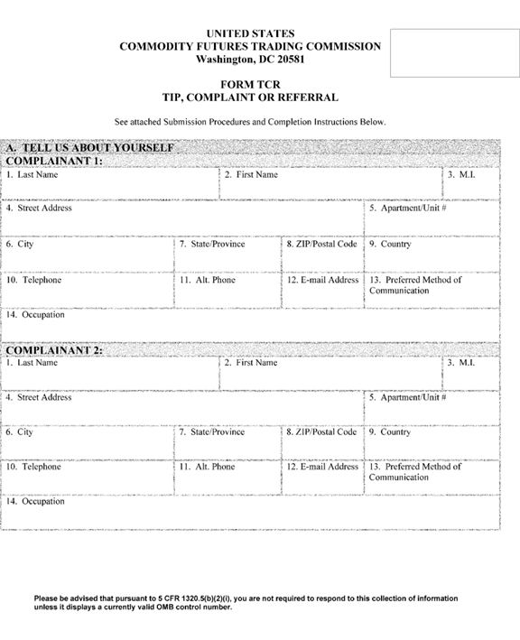

**[*24503]**



**[*24504]**

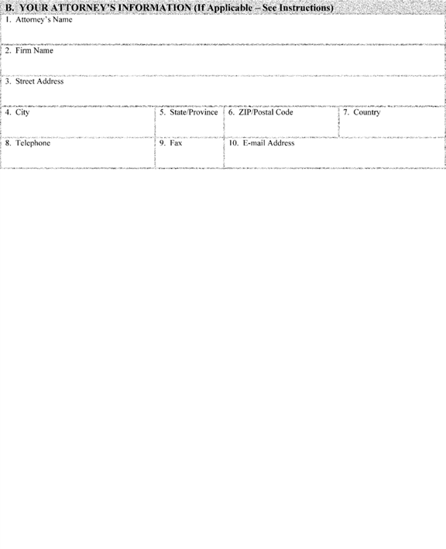

**[*24504]**



**[*24505]**

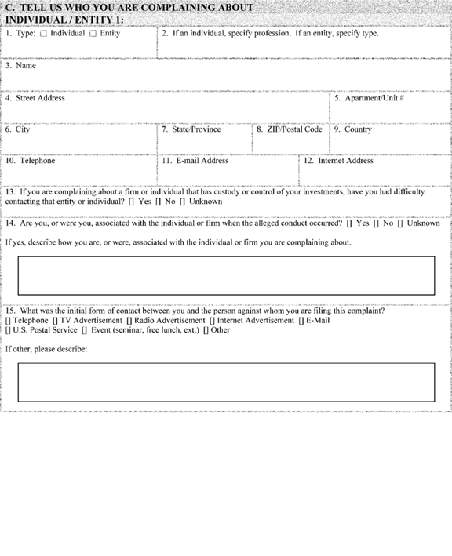

**[*24505]**



**[*24506]**

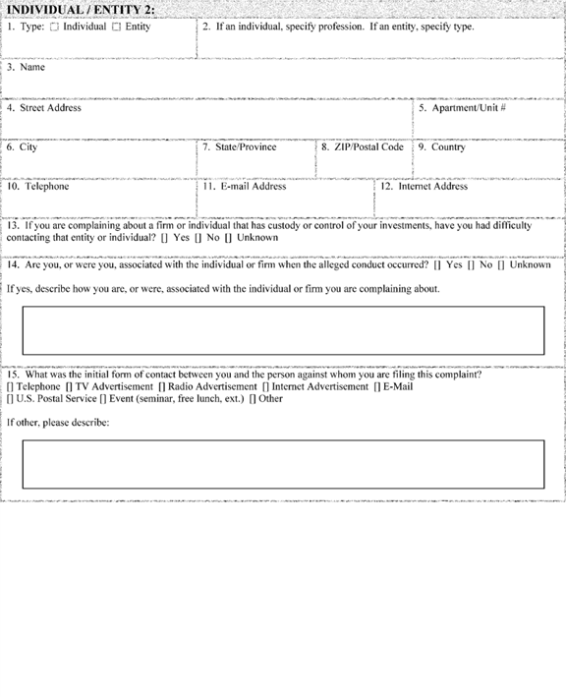

**[*24506]**



**[*24507]**

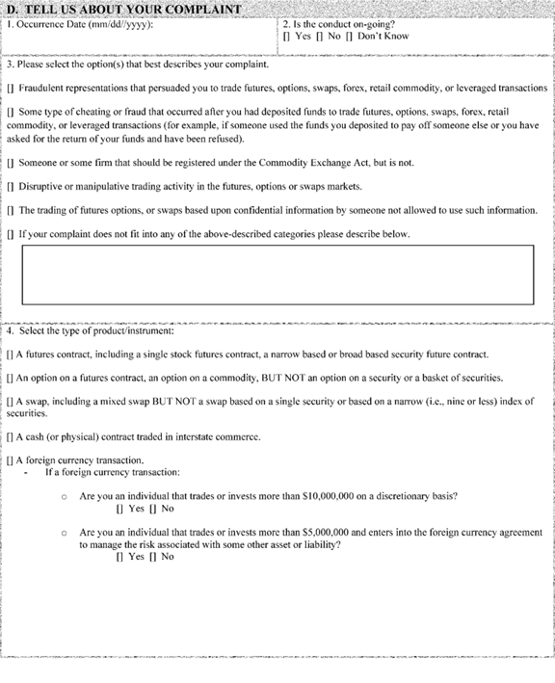

**[*24507]**



**[*24508]**

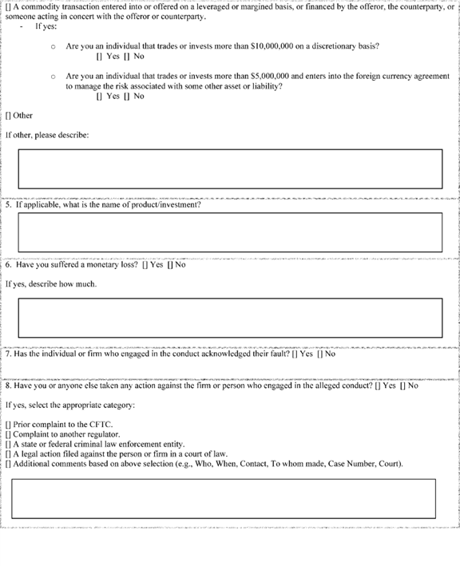

**[*24508]**



**[*24509]**

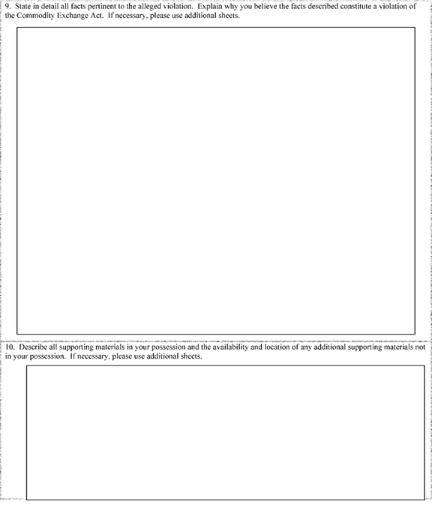

**[*24509]**



**[*24510]**

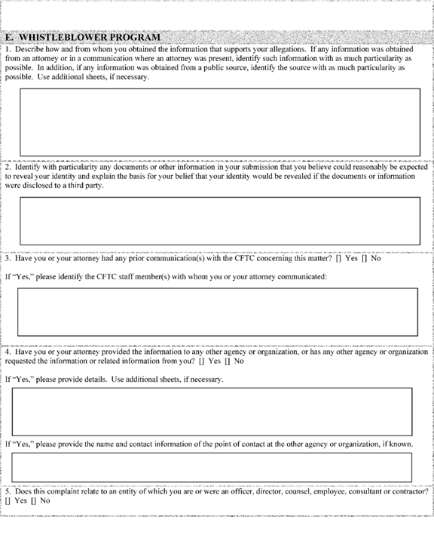

**[*24510]**



**[*24511]**

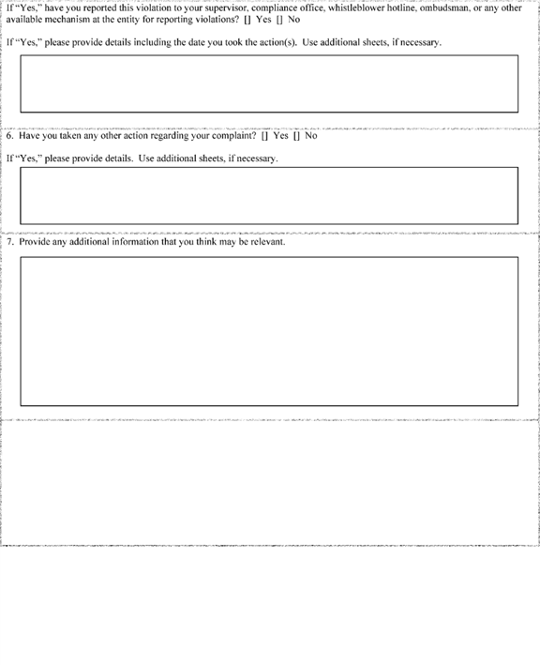

**[*24511]**



**[*24512]**

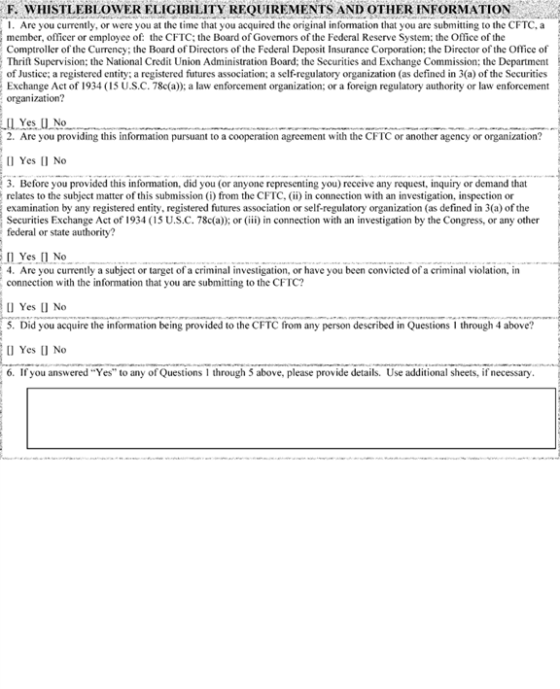

**[*24512]**



**[*24513]**

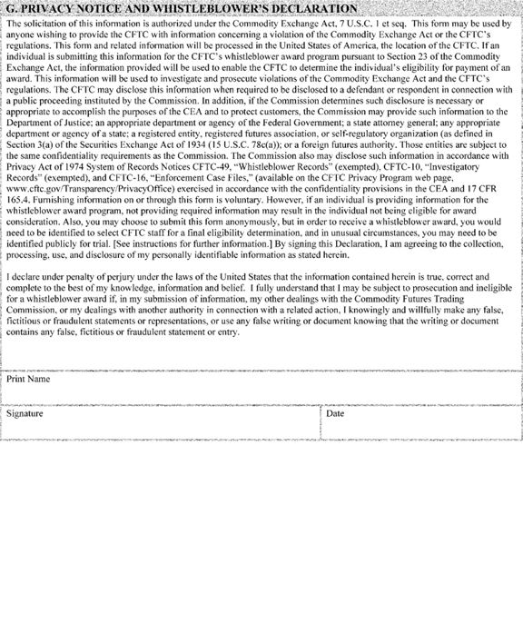

**[*24513]**

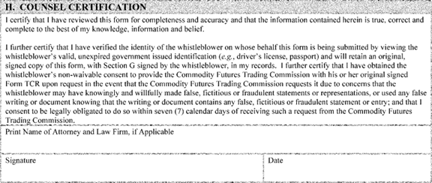

**Submission Procedures**

Questions concerning this form may be directed to Commodity Futures Trading Commission, Whistleblower Office, Three Lafayette Centre, 1155 21st Street NW., Washington, DC 20581.

* If you are submitting information for the CFTC's whistleblower award program, you *must* submit your information using this Form TCR.

1. You may submit this form electronically, through the Web portal found on the CFTC's Web site at [*http://www.whistleblower.gov*](http://www.whistleblower.gov)*.* You may also print this form and submit it by mail to Commodity Futures Trading Commission, Whistleblower Office, Three Lafayette Centre, 1155 21st Street, NW., Washington, DC 20581, or by facsimile to (202) 418-5975.
2. You have the right to submit information anonymously. If you do not submit anonymously, please note that the CFTC is required by law to maintain the confidentiality of any information which could reasonably identify you, and will only reveal such information in limited and specifically-defined circumstances. See [*7 U.S.C. 26(h)(2)*](https://advance.lexis.com/api/document?collection=statutes-legislation&id=urn:contentItem:4YF7-GT91-NRF4-40PG-00000-00&context=); [*17 CFR 165.4*](https://advance.lexis.com/api/document?collection=administrative-codes&id=urn:contentItem:5R5D-0TM0-008G-Y23B-00000-00&context=). However, in order to receive a whistleblower award, you will need to be identified to select CFTC staff for a final eligibility determination, and in unusual circumstances, you may need to be identified publicly for trial. You should therefore provide some means for the CFTC's staff to contact you, such as a telephone number or an email address.

**Instructions for Completing Form TCR**

*General*

All references to "you" and "your" are intended to mean the complainant.

1. **elf**

Questions 1-14: Please provide the following information about yourself:

[] last name, first name and middle initial;

[] complete address, including city, state and zip code;

[] telephone number and, if available, an alternate number where you can be reached;

[] your email address (to facilitate communications, we strongly encourage you to provide an email address, especially if you are filing anonymously);

[] your preferred method of communication; and

[] your occupation.

1. **ormation**

Complete this section only if you are represented by an attorney in this matter.

Questions 1-10: Provide the following information about your attorney:

[] attorney's name;

[] firm name;

[] complete address, including city, state and zip code;

[] telephone number and fax number; and

[] email address.

1. **Complaining About**

Question 1-2: Choose one of the following that best describes the individual's profession or the type of entity to which your complaint relates:

*For Individuals:* accountant, analyst, associated person, attorney, auditor, broker, commodity trading advisor, commodity pool operator, compliance officer, employee, executing broker, executive officer or director, financial planner, floor broker, floor trader, trader, unknown or other (specify).

*For Entities:* bank, commodity pool, commodity pool operator, commodity trading advisor, futures commission merchant, hedge fund, introducing broker, major swap participant, retail foreign exchange dealer, swap dealer, unknown or other (specify).

Questions 3-12: For each individual and/or entity, provide the following information, if known:

[] full name;

[] complete address, including city, state and zip code;

[] telephone number;

[] email address; and

[] internet address, if applicable.

Questions 13: If the firm or individual you are complaining about has custody or control of your investment, identify whether you have had difficulty contacting that firm or individual.

Question 14: Identify if you are, or were, associated with the individual or firm you are complaining about. If yes, describe how you are, or were, associated with the individual or firm you are complaining about.

Question 15: Identify the initial form of contact between you and the person against whom you are filing this complaint.

1. **Complaint**

Question 1: State the date (mm/dd/yyyy) that the alleged conduct occurred or began.

Question 2: Identify if the conduct is on-going.

Question 3: Choose the option that you believe best describes the nature of your complaint. If you are alleging more **[*24514]** than one violation, please list all that you believe may apply.

Question 4: Select the type of product or instrument you are complaining about.

Question 5: If applicable, please name the product or instrument. If yes, please describe.

Question 6: Identify whether you have suffered a monetary loss. If yes, please describe.

Question 7: Identify if the individual or firm you are complaining about acknowledged their fault.

Question 8: Indicate whether you have taken any other action regarding your complaint, including whether you complained to the CFTC, another regulator, a law enforcement agency, or any other agency or organization, or initiated legal action, mediation, arbitration or any other action.

If you answered yes, provide details, including the date on which you took the action(s) described, the name of the person or entity to whom you directed any report or complaint, and contact information for the person or entity, if known, and the complete case name, case number and forum of any legal action you have taken.

Question 9: State in detail all facts pertinent to the alleged violation. Explain why you believe the facts described constitute a violation of the Commodity Exchange Act.

Question 10: Describe all supporting materials in your possession and the availability and location of any additional supporting materials not in your possession.

1. **am**

Question 1: Describe how you obtained the information that supports your allegations. If any information was obtained from an attorney or in a communication where an attorney was present, identify such information with as much particularity as possible. In addition, if any information was obtained from a public source, identify the source with as much particularity as possible.

Question 2: Identify any documents or other information in your submission on this Form TCR that you believe could reasonably be expected to reveal your identity. Explain the basis for your belief that your identity would be revealed if the documents or information were disclosed to a third party.

Question 3: State whether you or your attorney have had any prior communication(s) with the CFTC concerning this matter.

If you answered "yes", identify the CFTC staff member(s) with whom you or your attorney communicated.

Question 4: Indicate whether you or your attorney have provided the information you are providing to the CFTC to any other agency or organization, or whether any other agency or organization has requested the information or related information from you.

If you answered "yes", provide details and the name and contact information of the point of contact at the other agency or organization, if known.

Question 5: Indicate whether your complaint relates to an entity of which you are, or were in the past, an officer, director, counsel, employee, consultant or contractor.

If you answered "yes", state whether you have reported this violation to your supervisor, compliance office, whistleblower hotline, ombudsman, or any other available mechanism at the entity for reporting violations. Please provide details, including the date on which you took the action.

Question 6: Indicate whether you have taken any other action regarding your complaint, including whether you complained to the CFTC, another regulator, a law enforcement agency, or any other agency or organization, or initiated legal action, mediation, arbitration or any other action.

If you answered "yes", provide details, including the date on which you took the action(s) described, the name of the person or entity to whom you directed any report or complaint, and contact information for the person or entity, if known, and the complete case name, case number and forum of any legal action you have taken.

Question 7: Provide any additional information you think may be relevant.

1. **bility Requirements and Other Information**

Question 1: State whether you are currently, or were at the time that you acquired the original information that you are submitting to the CFTC, a member, officer or employee of: The CFTC; the Board of Governors of the Federal Reserve System; the Office of the Comptroller of the Currency; the Board of Directors of the Federal Deposit Insurance Corporation; the Director of the Office of Thrift Supervision; the National Credit Union Administration Board; the Securities and Exchange Commission; the Department of Justice; a registered entity; a registered futures association; a self-regulatory organization (as defined in 3(a) of the Securities Exchange Act of 1934 ([*15 U.S.C. 78c(a)*](https://advance.lexis.com/api/document?collection=statutes-legislation&id=urn:contentItem:4YF7-GHC1-NRF4-407J-00000-00&context=)); a law enforcement organization; or a foreign regulatory authority or law enforcement organization.

Question 2: State whether you are providing the information pursuant to a cooperation agreement with the CFTC or with another agency or organization.

Question 3: State whether you are providing this information before you (or anyone representing you) received any request, inquiry or demand that relates to the subject matter of this submission (i) from the CFTC, (ii) in connection with an investigation, inspection or examination by any registered entity, registered futures association or self-regulatory organization (as defined in 3(a) of the Securities Exchange Act of 1934 ([*15 U.S.C. 78c(a)*](https://advance.lexis.com/api/document?collection=statutes-legislation&id=urn:contentItem:4YF7-GHC1-NRF4-407J-00000-00&context=)), or (iii) in connection with an investigation by the Congress, or any other federal or state authority.

Question 4: State whether you are currently a subject or target of a criminal investigation, or whether you have been convicted of a criminal violation, in connection with the information you are submitting to the CFTC.

Question 5: State whether you acquired the information you are providing to the CFTC from any individual described in Questions 1 through 4 of this section.

Question 6: If you answered yes to any of Questions 1 through 5, please provide details.

1. **Whistleblower's Declaration**

You must sign this Declaration if you are submitting this information pursuant to the CFTC whistleblower program and wish to be considered for an award. If you are submitting your information using the electronic version of Form TCR through the CFTC's web portal, you must check the box to agree with the declaration. If you are submitting your information anonymously, you must still sign this Declaration (using the term "anonymous") or check the box as appropriate, and, if you are represented by an attorney, you must provide your attorney with the original of this signed form, or maintain a copy for your own records.

1. **on**

If you are submitting this information pursuant to the CFTC whistleblower program and you are doing so anonymously through an attorney, your attorney must sign the Counsel Certification Section. If your attorney is submitting your information using the electronic version of Form TCR through the CFTC's web portal, he/she must check the box to agree with the **[*24515]** certification. If you are represented in this matter but you are not submitting your information pursuant to the CFTC whistleblower program, your attorney does not need to sign this Certification or check the box.

**[*24516]**

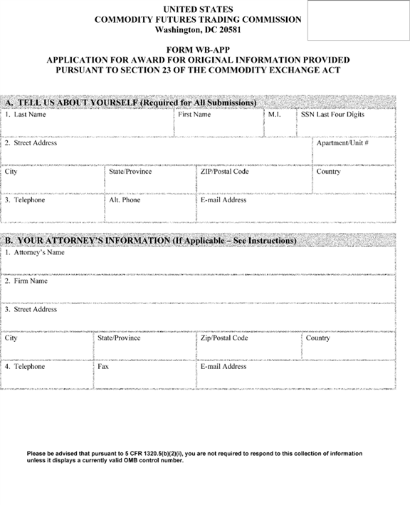

**[*24516]**



**[*24517]**

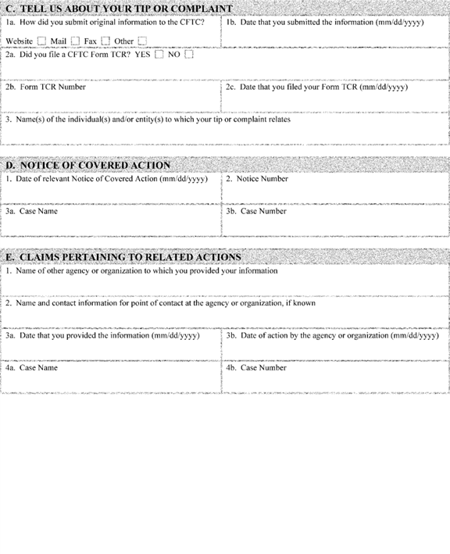

**[*24517]**



**[*24518]**

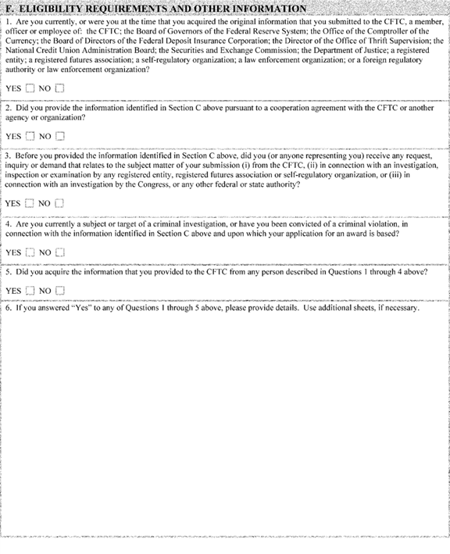

**[*24518]**



**[*24519]**



**[*24519]**

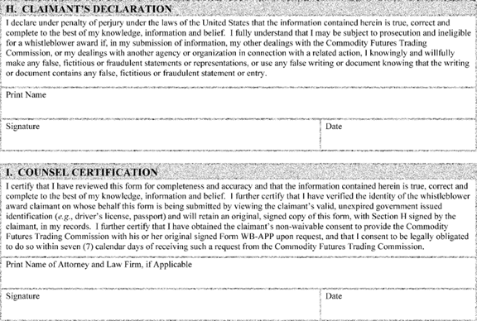

**Privacy Act Statement**

This notice is given under the Privacy Act of 1974. The Privacy Act requires that the Commodity Futures Trading Commission (CFTC) inform individuals of the following when asking for information. The solicitation of this information is authorized under the Commodity Exchange Act, [*7 U.S.C. 1*](https://advance.lexis.com/api/document?collection=statutes-legislation&id=urn:contentItem:4YF7-GRC1-NRF4-427C-00000-00&context=) *et seq.* The information provided will enable the CFTC to determine the whistleblower award claimant's eligibility for payment of an award pursuant to Section 23 of the Commodity Exchange Act and Part 165 of the CFTC's ***regulations***. This information will be used to investigate and prosecute violations of the Commodity Exchange Act and the CFTC's ***regulations***. This information may be disclosed to federal, state, local or foreign agencies or other authorities responsible for investigating, prosecuting, enforcing or implementing laws, rules or ***regulations*** implicated by the information consistent with the confidentiality requirements set forth in Section 23 of the Commodity Exchange Act and Part 165 of the CFTC's ***regulations***. The information will be maintained and additional disclosures may be made in accordance with System of Records Notices CFTC-49, "Whistleblower Records" (exempted), CFTC-10, "Investigatory Records" (exempted), and CFTC-16, "Enforcement Case Files." The CFTC requests the last four digits of the claimant's Social Security Number for use as an individual identifier to administer and manage the whistleblower award program. Executive Order 9397 (November 22, 1943) allows federal agencies to use the Social Security Number as an individual identifier. Furnishing the information is voluntary. However, if an individual is providing information for the whistleblower award program, not providing required information may result in the individual not being eligible for award consideration.

Questions concerning this form may be directed to Commodity Futures Trading Commission, Whistleblower Office, Three Lafayette Centre, 1155 21st Street NW., Washington, DC 20581.

**Submission Procedures**

* This form *must* be used by persons making a claim for a whistleblower award in connection with information provided to the CFTC, or to another agency or organization in a related action. In order to be deemed eligible for an award, you must meet all the requirements set forth in Section 23 of the Commodity Exchange Act and Part 165 of the CFTC's ***regulations***.

1. You must sign the Form WB-APP as the claimant. If you wish to submit the Form WB-APP anonymously, you must do so through an attorney, your attorney must sign the Counsel Certification Section of the Form WB-APP that is submitted to the CFTC, and you must give your attorney your original signed Form WB-APP so that it can be produced to the CFTC upon request.
2. During the whistleblower award claim process, your identity must be verified in a form and manner that is acceptable to the CFTC prior to the payment of any award.
3. If you are filing your claim in connection with information that you provided to the CFTC, then your Form WB-APP, and any attachments thereto, must be received by the CFTC within ninety (90) days of the date of the Notice of Covered Action, or the date of a final **[*24520]** judgment in a related action to which the claim relates.
4. If you are filing your claim in connection with information that you provided to another agency or organization in a related action, then your Form WB-APP, and any attachments thereto, must be received by the CFTC as follows:
5. If a final order imposing monetary sanctions has been entered in a related action at the time that you submit your claim for an award in connection with a CFTC action, you may submit your claim for an award in that related action on the same Form WB-APP that you use for the CFTC action.
6. If a final order imposing monetary sanctions in a related action has not been entered at the time that you submit your claim for an award in connection with a CFTC action, you must submit your claim on Form WB-APP within ninety (90) days of the issuance of a final order imposing sanctions in the related action.
7. If a final order imposing monetary sanctions in a related action relates to a judicial or administrative action brought by the Commission under the Commodity Exchange Act that is not a covered judicial or administrative action, and therefore there would not be a Notice of Covered Action, you must submit your claim on Form WB-APP for an award in connection with the related action within ninety (90) calendar days following either (1) the date of issuance of a final order in the related action, if that date is after the date of issuance of the final judgment in the related Commission judicial or administrative action; or (2) the date of issuance of the final judgment in the related Commission judicial or administrative action, *i.e.,* the date the related action becomes a related action, if the date of issuance of the final order in the related action precedes the final judgment in the related Commission judicial or administrative action.
8. To submit your Form WB-APP, you may print it and either submit it by mail to Commodity Futures Trading Commission, Whistleblower Office, Three Lafayette Centre, 1155 21st Street NW., Washington, DC 20581, or by facsimile to (202) 418-5975. You also may submit this form electronically, through the web portal found on the CFTC's Web site at [*http://www.cftc.gov*](http://www.cftc.gov)*,* which is also accessible from the CFTC Whistleblower Program Web site at [*www.whistleblower.gov*](http://www.whistleblower.gov)*.*

**Instructions for Completing Form WB-APP**

*General*

All references to "you" and "your" are intended to mean the whistleblower award claimant.

1. **elf**

Questions 1-3: Please provide the following information about yourself:

. last name, first name, middle initial and the last four digits of your Social Security Number;

. complete address, including city, state and zip code;

. telephone number and, if available, an alternate number where you can be reached; and

. your email address (to facilitate communications, we strongly encourage you to provide an email address, especially if you are making your claim anonymously).

1. **ormation**

Complete this section only if you are represented by an attorney in this matter. Questions 1-4: Provide the following information about your attorney:

. attorney's name;

. firm name;

. complete address, including city, state and zip code;

. telephone number and fax number; and

. email address.

1. **Tip or Complaint**

Question 1a: Indicate the manner in which you submitted your original information to the CFTC.

Question 1b: Provide the date on which you submitted your original information to the CFTC.

Question 2a: State whether you filed a CFTC Form TCR.

Question 2b: If you filed a CFTC Form TCR, provide the Form's number.

Question 2c: If you filed a CFTC Form TCR, provide the date on which you filed the Form.

Question 3: Provide the name(s) of the individual(s) and/or entity(s) to which your tip or complaint relates.

1. **ction**

The process for making a claim for a whistleblower award for a CFTC action begins with the publication of a "Notice of Covered Action" on the CFTC's Web site. This Notice is published whenever a judicial or administrative action brought by the CFTC results in the imposition of monetary sanctions exceeding $ 1,000,000. The Notice is published on the CFTC's Web site subsequent to the entry of a final judgment or order in the action that by itself, or collectively with other judgments or orders previously entered in the action, exceeds the $ 1,000,000 threshold required for a whistleblower to be potentially eligible for an award. The CFTC will not contact whistleblower claimants directly as to Notices of Covered Actions; prospective claimants should monitor the CFTC Web site for such Notices.

Question 1: Provide the date of the Notice of Covered Action to which this claim relates.

Question 2: Provide the notice number of the Notice of Covered Action.

Question 3a: Provide the case name referenced in the Notice of Covered Action.

Question 3b: Provide the case number referenced in the Notice of Covered Action.

1. **o Related Actions**

Question 1: Provide the name of the agency or organization to which you provided your information.

Question 2: Provide the name and contact information for your point of contact at the agency or organization, if known.

Question 3a: Provide the date on which you provided your information to the agency or organization referenced in Question 1 of this section.

Question 3b: Provide the date on which the agency or organization referenced in Question 1 of this section filed the related action that was based upon the information that you provided.

Question 4a: Provide the case name of the related action.

Question 4b: Provide the case number of the related action.

1. **ments and Other Information**

Question 1: State whether you are currently, or were at the time that you acquired the original information that you submitted to the CFTC, a member, officer or employee of: The CFTC; the Board of Governors of the Federal Reserve System; the Office of the Comptroller of the Currency; the Board of Directors of the Federal Deposit Insurance Corporation; the Director of the Office of Thrift Supervision; the National Credit Union Administration Board; the Securities and Exchange Commission; the Department of Justice; a registered entity; a registered futures association; a self-regulatory organization; a law enforcement organization; or a foreign regulatory authority or law enforcement organization. **[*24521]**

Question 2: State whether you provided the information that you submitted to the CFTC pursuant to a cooperation agreement with the CFTC, or with any other agency or organization.

Question 3: State whether you provided this information before you (or anyone representing you) received any request, inquiry or demand that relates to the subject matter of your submission (i) from the CFTC, (ii) in connection with an investigation, inspection or examination by any registered entity, registered futures association or self-regulatory organization, or (iii) in connection with an investigation by the Congress, or any other federal or state authority.

Question 4: State whether you are currently a subject or target of a criminal investigation, or whether you have been convicted of a criminal violation, in connection with the information that you submitted to the CFTC and upon which your application for an award is based.

Question 5: State whether you acquired the information that you provided to the CFTC from any individual described in Questions 1 through 4 of this section.

Question 6: If you answered yes to any of Questions 1 through 5 of this section, please provide details.

1. **d**

This section is optional. Use this section to explain the basis for your belief that you are entitled to an award in connection with your submission of information to the CFTC, or to another agency in connection with a related action. Specifically, address why you believe that you voluntarily provided the CFTC with original information that led to the successful enforcement of a judicial or administrative action filed by the CFTC, or a related action. Refer to § 165.9 of the CFTC's ***regulations*** for further information concerning the relevant award criteria.

Section 23(c)(1)(B) of the Commodity Exchange Act and § 165.9(a) of the CFTC's ***regulations*** require the CFTC to consider the following factors in determining the amount of an award: (1) The significance of the information provided by a whistleblower to the success of the CFTC action or related action; (2) the degree of assistance provided by the whistleblower and any legal representative of the whistleblower in the CFTC action or related action; (3) the programmatic interest of the CFTC in deterring violations of the Commodity Exchange Act (including ***regulations*** under the Act) by making awards to whistleblowers who provide information that leads to the successful enforcement of such laws; (4) whether the award otherwise enhances the CFTC's ability to enforce the Commodity Exchange Act, protect customers, and encourage the submission of high quality information from whistleblowers; and (5) potential adverse incentives from oversize awards. Address these factors in your response as well.

1. **ion**

You must sign this Declaration if you are submitting this claim pursuant to the CFTC whistleblower program and wish to be considered for an award. If you are submitting your claim anonymously, you must do so through an attorney, and you must provide your attorney with your original signed Form WB-APP.

1. **on**

If you are submitting this claim pursuant to the CFTC whistleblower program anonymously, you must do so through an attorney, and your attorney must sign the Counsel Certification Section.

Issued in Washington, DC, on May 22, 2017, by the Commission.

**Christopher J. Kirkpatrick,**

*Secretary of the Commission.*

**Note:** The following appendix will not appear in the Code of Federal ***Regulations***.

**Appendix** to Whistleblower Awards Process--Commission Voting Summary

On this matter, Acting Chairman Giancarlo and Commissioner Bowen voted in the affirmative. No Commissioner voted in the negative.

[FR Doc. 2017-10801 Filed 5-26-17; 8:45 am]

BILLING CODE 6351-01-P

**Dates**

**DATES:** This final rule is effective July 31, 2017.

**Contacts**

**FOR FURTHER INFORMATION CONTACT:** Anthony Hays, Counsel, (202) 418-5584, [*ahays@cftc.gov*](mailto:ahays@cftc.gov)*,* Commodity Futures Trading Commission, Three Lafayette Centre, 1155 21st Street NW., Washington, DC 20581.

FEDERAL REGISTER

**End of Document**